Homefinder Procedural Guidance

Based Upon Current North Tyneside Council Lettings Policy Implemented 2nd December 2019

**Tyne and Wear Homes Applications Process for Homefinder and Housing Advice Officers**

**Registration Process**

Customer presents in person or makes contact via email or telephone to Housing Advice Team or Homefinder

**Officer assesses that the customer is not homeless or threatened with homelessness within the next 56 days**

Homefinder Officer will complete application / assist with completion of application

Application to be assessed by Homefinder Officer in line with North Tyneside Council Lettings Policy - banding applied, account activated, and customer informed of the outcome in writing

**If the customer advises they are at risk of homelessness within the next 56 days**

Homefinder Officer registers the application then sends an email to Housing Advice email inbox – “Triage required - customer name, application reference number, telephone number and email address”

HAT will then contact the customer to assess if homelessness advice is required, note added to TWH application CRM by HAT officer stating outcome of the triage.

Homefinder maintain responsibility of the application and send out relevant communication to the customer. When Housing Advice Officers receive any documentation, they will attach this to the application and email Tyne & Wear Homes to advise for the application to be assessed.

**Following Assessment** - if the customer contacts Homefinder to advise that their situation has changed / there is an immediate threat of homelessness, the Homefinder Officer sends an email to the HAT inbox.

At point of “relief stage” HAT officer will update TWH application and send the customer a change of circumstances letter.

HAT Officer to update TWH application at each stage with any relevant involvement:

* Triage
* Prevention
* Relief
* Final Stage / Homelessness Decision

**Rough Sleepers / Roofless**

If a customer indicates that they are roofless / rough sleeping refer to HAT immediately for triage

**Ineligible Customers**

Checks show or customer gives information which causes their application to be ineligible to join Tyne and Wear Homes, as per NTC lettings policy page 11, section 4.2

Homefinder Officer will write to the customer advising they are ineligible to join Tyne and Wear Homes and that they will be referred to HAT for homelessness triage advice.

Homefinder would then refer the case to Housing Advice inbox if the applicant is threatened with Homelessness requesting a triage call.

Triage Officer would then complete a triage call and **Open Locata Case**

HAT may arrange an appointment for the customer to be seen by a Housing Advice Officer at a customer first centre convenient for them

Following initial appointment HAT Officer will:

* Update Abritas CRM with a note stating which stage of homelessness (i.e. prevention / relief and responsible HAT officer)
* Housing Advice Officer will attach any relevant information to Tyne and Wear Homes application and inform the responsible Homefinder Officer
* Update Locata

**Appeals / Review Requests**

Reviews of bandings are referred to the Housing Options Team Leader (Homefinder)

Reviews of Homeless decisions are referred to Housing Options Team Leader (Homelessness)

**Guide for Applicants and Staff Appendices**

**How to Register with Tyne and Wear Homes**

**To register with Tyne and Wear Homes (no existing or previous application)**

Visit [www.tyneandwearhomes.org.uk](http://www.tyneandwearhomes.org.uk)

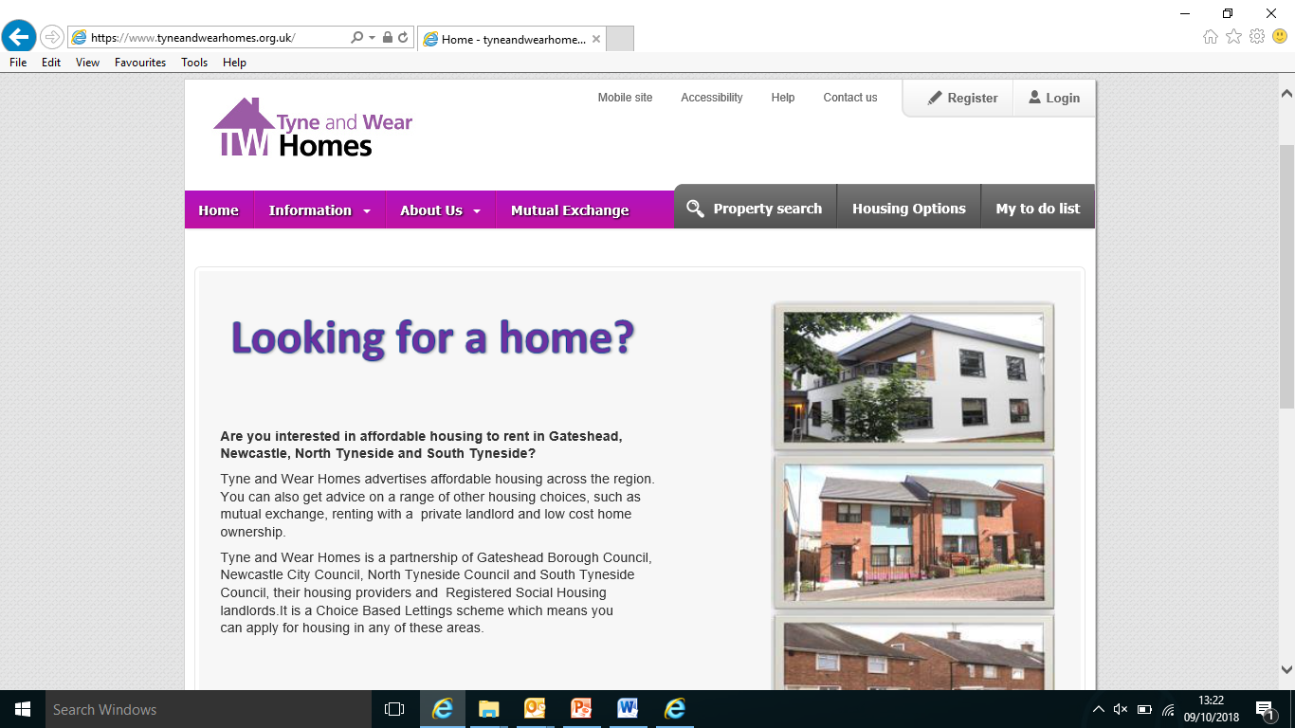

**Remember: - each authority has their own lettings policy; applicants will be assessed accordingly.**

**If an applicant has been previously registered with Tyne and Wear Homes**

click Login and will be presented with the screen below, the Applicant then enters their previous reference number for example 745620 and their memorable date, this is usually their date of birth

The applicant can then update / edit the existing application

(If an applicant cannot remember the date or ref number this can be requested from the Homefinder Team by Applicants on 0345 2000 102 or colleagues call internal extension 2515)

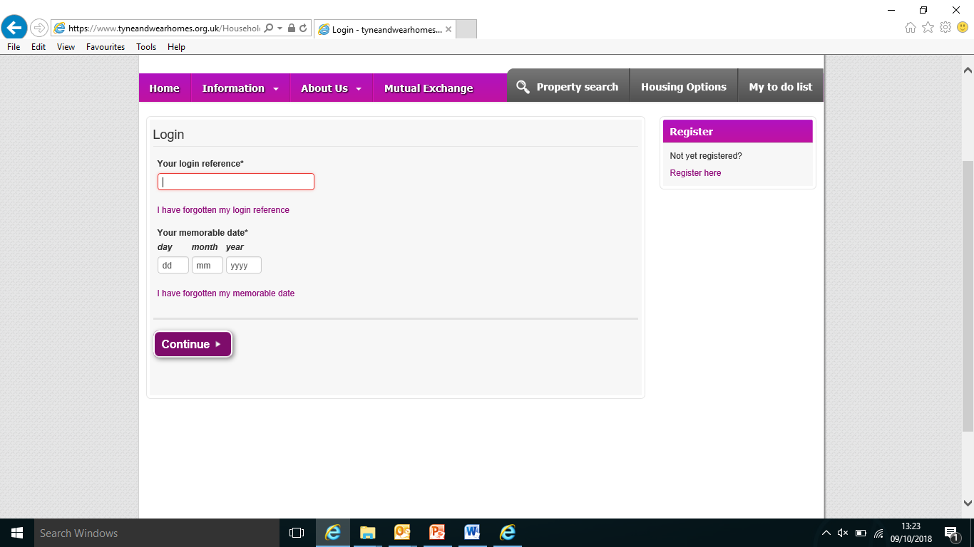

**Applicants whom haven’t registered with Tyne and Wear Homes previously**

Click on register and will be presented with the screen below:

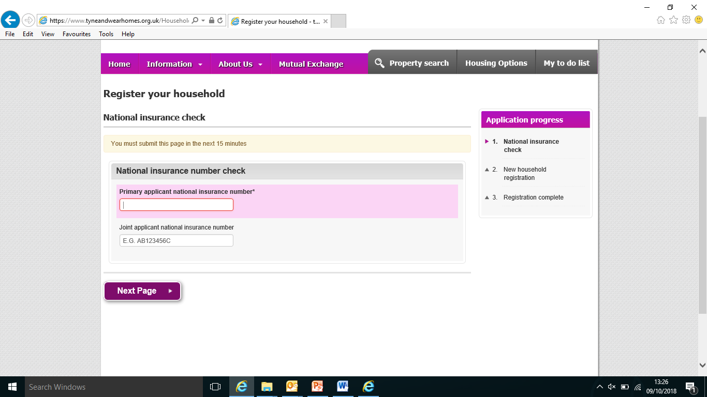

The Applicant is prompted to supply a NI number for them / any joint applicants

**New Household Registration**

The Applicant is asked for their personal details such as name, gender, nationality and ethnic origin

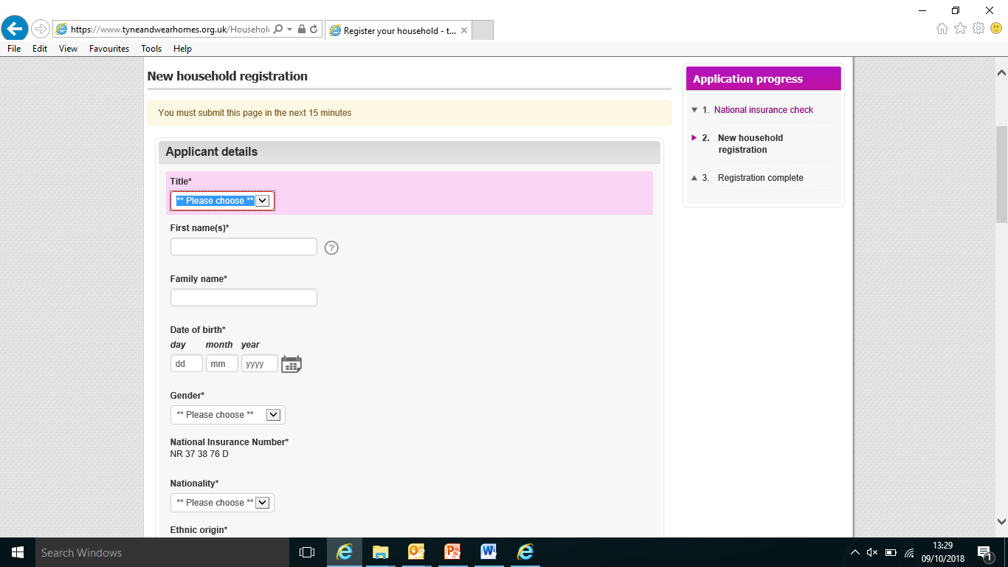

**Other Household members**

Add addition household members to the application, if a single applicant click “next page”

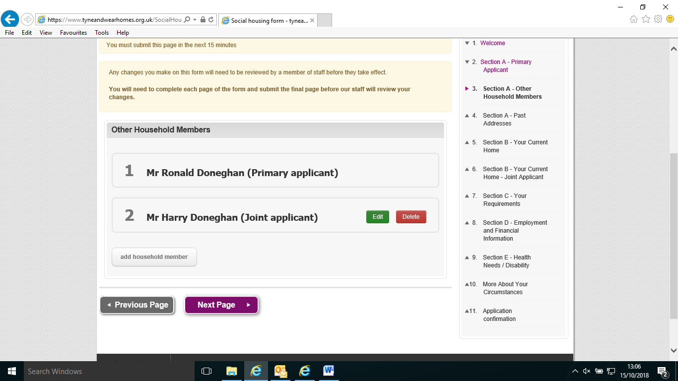

**Past Addresses**

NTC requires a six-year housing history for all applicants and household members; you cannot progress past this page without giving enough information

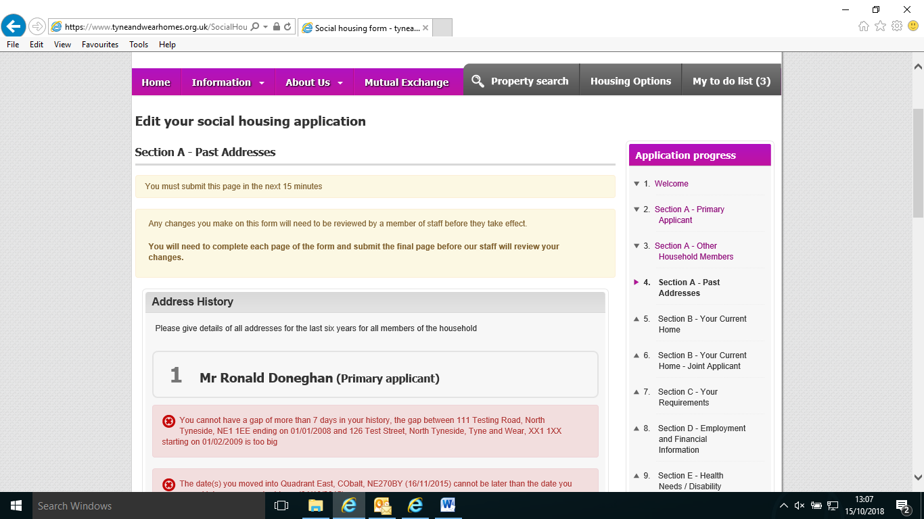

**Your current home**

The applicant is asked about the property they are currently living in and if they are having any difficulty in their home, how many bedrooms it has and the facilities

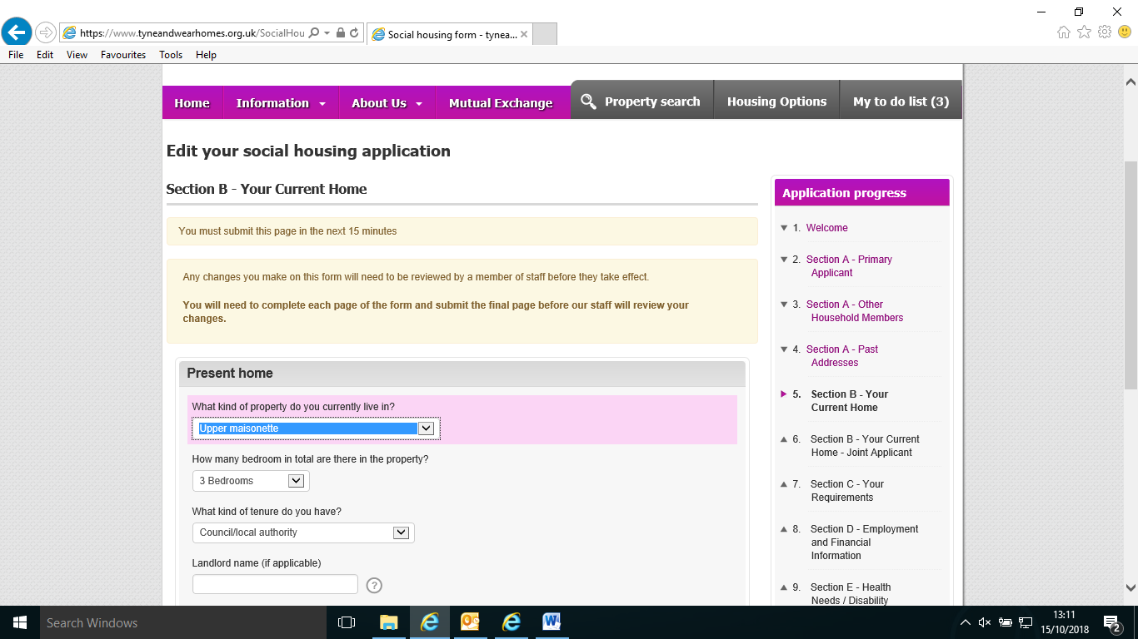

**Your Requirements and local connection to North Tyneside**

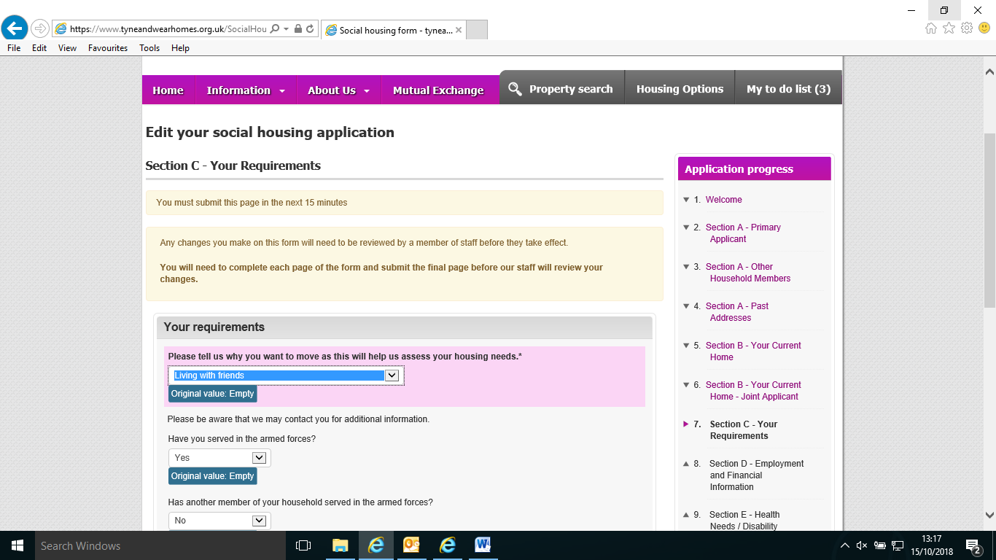

**Employment and financial information / arrears**

If the Applicant has arrears it is important that the details are entered here, and if there is a payment plan in place as we will use this information to decide if an Applicant in arrears is eligible to join Tyne and Wear Homes

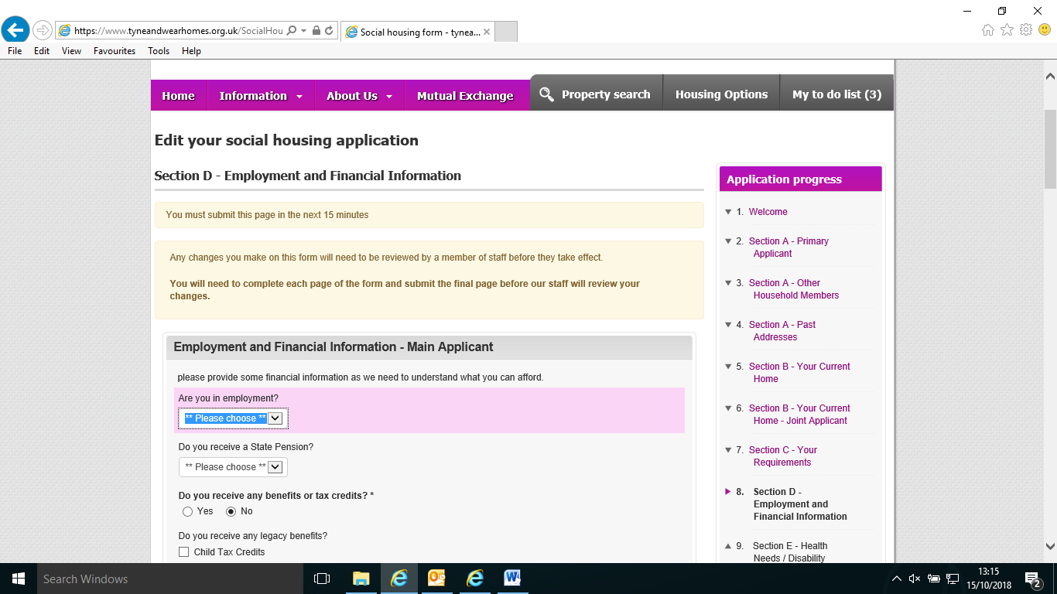

**Health needs and disability**

it is important that the Applicant provides as much information as possible to assist with assessment of their application, if the applicant declares medical conditions the HF team may send a medical questionnaire

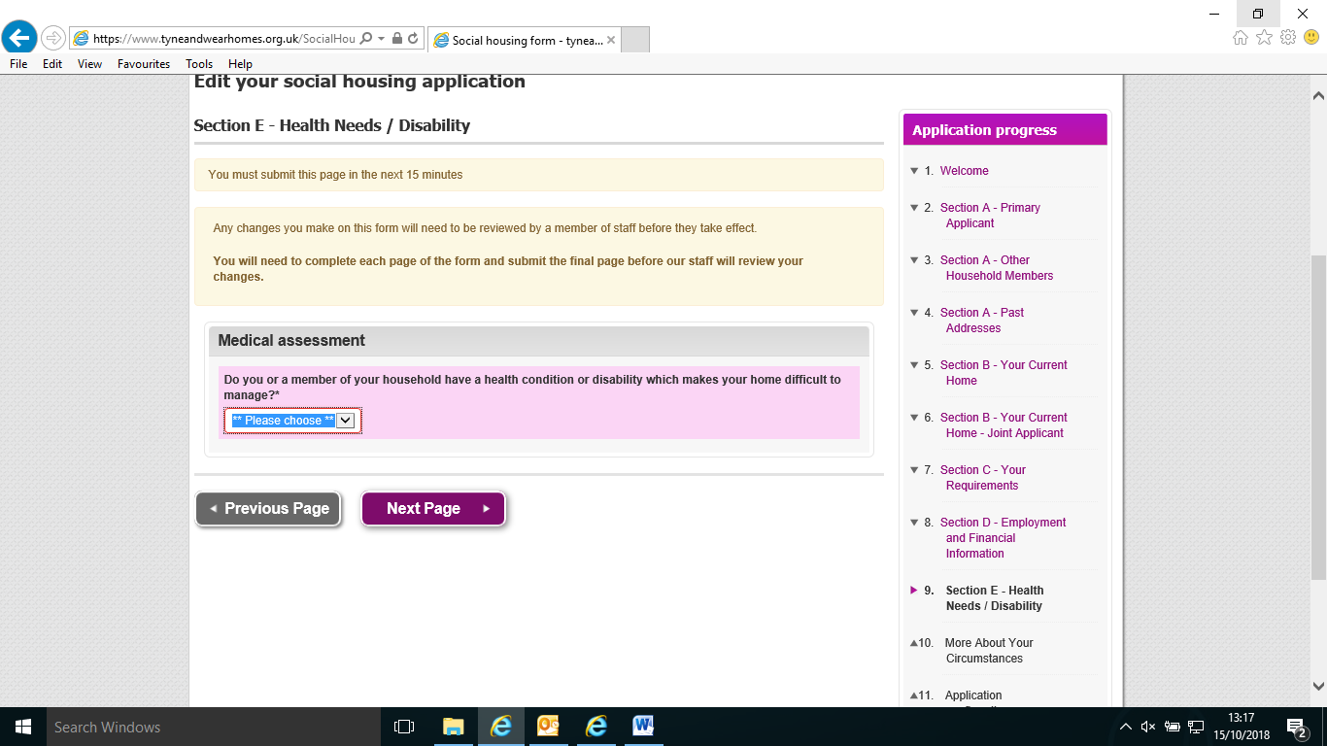

**More about your circumstances**

This section asks the Applicant to declare any unspect convicition, the “hover box” gives an explanation.

If a Applicant has unspent convictions they may not be allowed to join the housing register, Homefinder will write to the Applicant to explain if this is the case

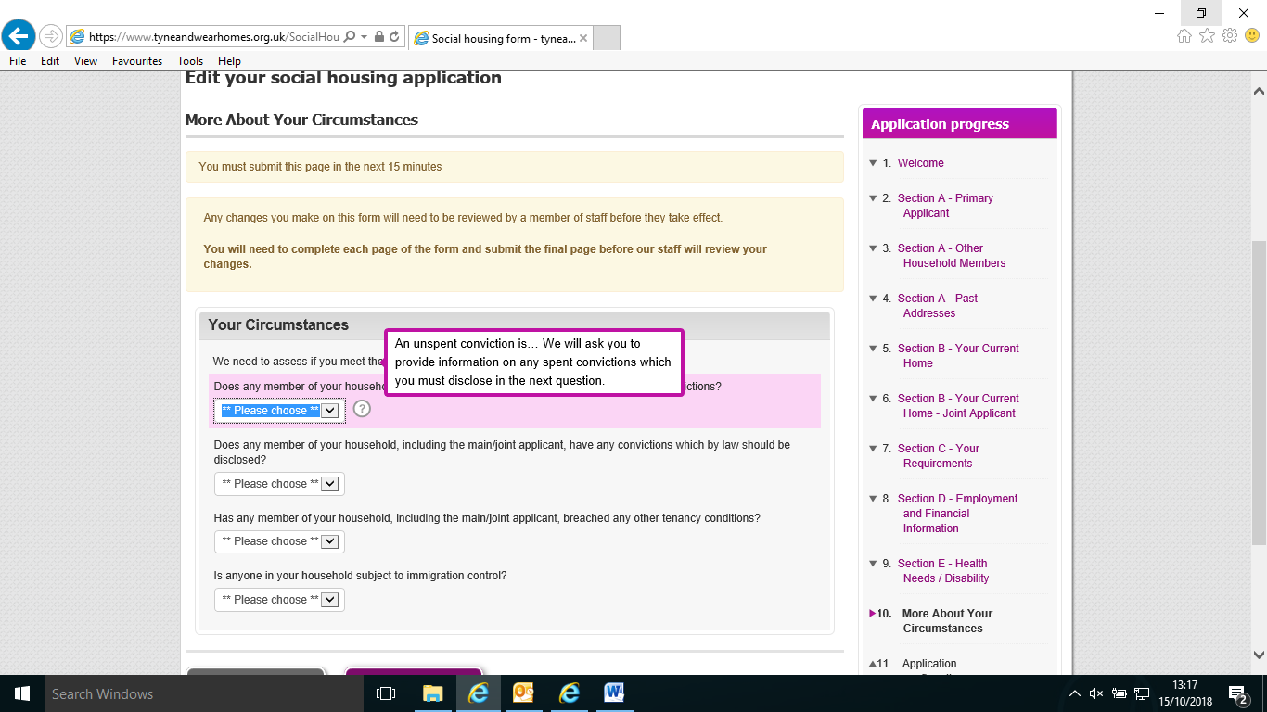

**Confirmation of Registration and Data Protection Statement**

The last screen reminds the applicant that if they provide false information this may affect their application and any offers of accommodation made to them.

**In all cases the following applies:**

**Homefinder Officer** Checks to be completed:

* Streetwise if there isnt an open case the Homefinder Officer advises Community Protection of the information received from applicant
* Liquid Logic
* Northgate
* Debtors System
* Checks with children’s services for example in the case of looked after children
* If customer has declared an unspent or previous conviction contact the customer by telephone to ask about the declaration, they have made
* Using the information gathered the Homefinder Officer makes the decision to allow the applicant to join the register or not
* In the case of being ineligible the officer writes to the customer to explain the reasons for ineligibility and what the customer needs to do in order to re-apply
* Landlord references to be applied for in all cases unless this would put the applicant at risk

**All welcome letters must state:**

* Which section of NTC policy the customer has been assessed under and a summary of this for example - “***your application has been assessed in line with North Tyneside Council Allocations Policy -* *Section 5.3 (b) High Housing Need (applicants with a local connection)there are concerns about safety, for example through a high risk of falling due to difficulties with access and adaptation of the home is not possible”***
* If a band 1 or 2 award Date and expiry / review date advising the customer that the priority may be removed in three months if they have not expressed interest in suitable properties
* Property types allowed / disallowed and reasons as per OT recommendations
* Areas not allowed, for example in the case of ASB/ Harassment cases

**Closure of Applications**

If an applicant contacts us to advise that they want their application to be closed the closure letter is to be sent

If an applicant contacts to advise they have moved home but would like to keep their application active – close the application, advise them to login and update their application, they will not receive the original application date and will be reassessed.

Incomplete applications are closed after 28 days, if the application does not have any attachments, if there are attachments contact the customer to ask if they still want to proceed and give them a 7-day deadline to complete

**Landlord References**

If an applicant has held a tenancy, then they must provide contact details for their current landlord and / or previous landlord in the case of the current tenancy being less than 12 months.

The Homefinder Team will apply for landlord references on behalf of the customer in all cases, using the standard landlord reference request form, before sending the form the officer completes the front page with the applicants name and address of the property for which the reference is required and places their own initials in the top right hand corner.

The Officer will allow 21 days in order to receive the reference. If the reference hasn’t been returned within 21 days, the HO will contact the applicant to advise we cannot progress the application without the LL reference.

If a returned reference contains any information which may affect the applicant’s eligibility to join the scheme the officer will discuss this with the applicant to gain more information for example … rent arrears / alleged anti-social behaviour / damage to the property.

If a customer is unable to provide a reference or there is a reason why a reference cannot be requested for example the customer is fleeing domestic abuse, harassment or violence and contacting the landlord may place the customer at increased risk we can accept 12 months bank statement or proof of rent payments – discuss with a Team Leader.

**Applicants Declaring Convictions**

Where a customer has indicated that they have a criminal conviction the officer processing the application will complete the usual checks as detailed on Page 13 and decide as to whether to allow the applicant to join the housing register.

The officer can refer cases to the Homefinder Team Leader / Housing Options Team Leader(s) if they have followed the above steps and remain unsure about an applicant’s eligibility

* Applicants leaving prison must demonstrate that their behaviour has changed over 12 months since being released from prison before applying to be rehoused in North Tyneside
* Applicants released on licence – if an applicant is subject to licence conditions or has an order imposed, they are ineligible to join the register until 12 months after the licence has been issued - ***for example licence issued 12/12/2019 – applicant is ineligible until 12/12/2020***
* It is the applicants responsibility to provide evidence from relevant professionals / support agencies which shows that they have not re-offended or engaged in criminal behaviour, some convictions such as serious sexual assaults / public protection offences are never spent however if the applicant has not re-offended in the last 12 months and has complied with probation they are eligible to join
* Supporting information can be sought with the applicant’s permission from Probation / Support Workers
* Before completing a home, visit officers must complete their own risk assessment
* Once a conviction, caution, reprimand or final warning becomes spent, it does not need to be disclosed when applying for housing.
* It is against the law for an organisation to obtain information about an individual’s spent cautions or convictions.

**MAAPA Applicants**

Applications assessed inline with policy. Team Leader will request information from Police / Community Protection / Probation Worker and make a decision on eligibility.

If applicant is found to be ineligible for Homefinder letter sent to the applicant to advise of ineligibility and reason for this.

MAAPA applicants may qualify for a direct let:

* Homeless applicants – direct offer request to be submitted by the Housing Advice Officer
* Applicant is involved with Community Protection direct offer request submitted by CP
* Current tenant - the direct offer request will be submitted by Neighbourhood Team.

**Anti-Social Behaviour**

North Tyneside Council is committed to resolving and taking action against perpetrators of Anti-Social behaviour, this does not warrant a move in all cases, we must be given the opportunity to address the anti-social behaviour before priority is awarded for rehousing.

Where an applicant states the main reason for moving is due to suffering anti- social behaviour in their current home the officer processing the application must check Streetwise for any information relevant to the case.

If there is a current case and the applicant has provided you with new /additional information – send an email to the Community Protection Email Inbox.

If there is no case open - send an email to the Community Protection Email Inbox, advise the customer you have done this, and they will be contacted by the CP Team / if applicable offered Victim Support.

Any support from Northumbria Police supporting a move for a customer must come from a Sergeant; this has been agreed with North Tyneside Inspectors.

The police must advise what risk level the applicants are if they remain in their home.

Non council tenants must be asked what advice or support has been given to them by their landlord and if applicable any action taken.

If an applicant advises their reason for rehousing is due to suffering from ASB severely affecting their quality life

* Check Streetwise for details of case
* Are there multiple victims?
* What if any action has been taken against the perpetrator?
* Is there any legal action in process / notices issued?
* Is there an alternative to rehousing?
* What level of risk do the police place the victim at- are they supporting a move
* Are there any areas that the victim is unable to live? Consider where they currently live and where the perpetrator lives, if necessary, use restrictions in the back office

Officer:

* Confirm outcome in writing to customer quoting correct section of policy
* Update back office with band award and review date
* Place review date in diary

**Armed Forces**

Under section 5.3 High Housing need (page19/20) applicants leaving the armed forces and applying for rehousing are to be awarded Band 2 once discharge paperwork has been received, in order to qualify for this priority, the following criteria applies:

* The applicant applies within 5 years of discharge from the Armed Forces
* The applicant is a bereaved spouse or partner of a deceased member of the armed forces and they are having to leave martial accommodation
* The applicant is actively serving in the armed forces and due to leave within 6 months
* The priority is only awarded **once**
* Where there has been a relationship breakdown and the spouse or partner of the serving officer is required to leave tied accommodation, the priority will be awarded if this home is their settled accommodation / main home for a period of at least three months with supporting evidence from the Armed Forces Accommodation Service. (see Laura Potter if any assistance required)
* Ex Armed Forces Personnel currently living in supported accommodation in Avondale, Byker being asked to leave are awarded Band 2 Supported Accommodation
* If a person in Armed Forces has to leave the Armed Forces and they have been paid a lump some from the Ministry of defence then these monies would be disregarded during the assessment process.
* If the applicant’s adult children have to remain in the borough for example parents are stationed elsewhere in the country. The adult child would be considered for succession by Neighbourhood if a Council tenancy. Should the adult child not be eligible for succession they would be treat like any other person who cannot remain in the family home in line with the lettings policy and considered for a direct let.
* If the adult child’s parents are not NT Council tenants they would need to make an application under the lettings policy and be assessed in line with the policy and threatened homelessness. In those circumstances it would be expected that a Band 2 award would be given in line with :

1. People living in insanitary or overcrowded or unsatisfactory housing conditions by virtue of….

Please see the North Tyneside Letting Policy for further guidance or speak with Team Leader

**Applications from staff members and any supporting documentation**

Supporting medical information or any other sensitive documentation in relation to a member of North Tyneside Council staff in support of their application to be housed is to be given to a Housing Options Team Leader, they will scan the information onto Abritas securely

**Band 1 – Urgent and High Housing Need**

1. Hospital Discharge
2. Child Experiencing Abuse
3. Severe Domestic Abuse
4. Readmission to Residential Care
5. Child Being Accommodated
6. Witness / Victim of Crime / Violence / Severe Harassment
7. Statutory Overcrowding
8. National Witness Mobility Scheme
9. Present Home Unsuitable for Adaption (does not allow essential health treatment), Substantial Risk if remain in Current Home, Unable to Live in Current Home

**Band 1 – Urgent and High Housing Need / Band 2 High Housing Need (applicants with a local connection)**

Officers once satisfied that the case meets the criteria as below complete a Band 1 award pro-forma and pass to Team Leader or above for authorisation.

Update back office; enter review date three months from the award date and write to main applicant(s) using relevant letter stating:

Band 1&2 is awarded forthree months and will be reviewed three months after the award date.

Once expired if the customer hasn’t successfully been rehoused review the application and any bids placed, complete the review proforma and send to Team Leader.

1. **Hospital Discharge (section 5.2, (aii) page 16)**

The applicant is in hospital or residential care awaiting discharge to a suitable home and their present home is unsafe or discharge is prevented by their housing situation.

The situation must be confirmed in writing by a health professional and a discharge date given in order to award this band.

If applicable a care/ support plan may be required in order to determine the needs of the customer and their housing requirements check Liquid Logic for this information or involvements, Social Worker involvement.

If the customer has physical disabilities or adaptations may be required in the future – HO to complete a referral to the Housing Occupational Therapy Team.

1. **Child Experiencing Abuse (Section 5.2 (d) page 17)**

A child experiencing abuse needs to be moved away, to protect their safety and reduce the risk of further abuse from the perpetrator. This must be confirmed by a health or social care professional.

1. **Readmission to Residential Care – (Section 5.2, (b)page 17)**

There is a strong likelihood of admission to residential care of an applicant or member or his/her household, if re-housing is not made and this is confirmed by a health or social care professional.

1. **Child Being Accommodated (Section 5.2, (b) page 15)**

There is a strong likelihood of a child being taken into care if re-housing is not made and this is confirmed by an appropriate social care professional.

Confirmation can include a Special Guardianship Order, an email or letter of support from a Social Worker or Family Partner, confirming Adoption or Fostering arrangements.

If the child is subject to a private family arrangement we need confirmation from the legal guardian and children’s social worker of the arrangement.

This priority will apply only to residents of North Tyneside and only to applicants applying to North Tyneside Council’s Fostering and Adoption Service, who have an established local connection and who require a larger home to allow fostering or adoption to take place; and where the resident has applied and been accepted onto the Tyne and Wear Homes Scheme (Council’s Housing Register and in line with the Council’s Lettings Policy and Procedures).

If an applicant has applied to North Tyneside Council’s Fostering and Adoption Service and has met the criteria at Stage 1 of the process and the application is to be progressed to Stage 2, the Fostering and Adoption Service will inform the Homefinder Team in writing who will then consider awarding a Band 2 (High Housing Need). Note: The Fostering and Adoption Service will need to check at point of application to adopt or foster, as to whether the applicant requires a larger home and has applied to Tyne and Wear Homes for re-housing.

Upon notification of the applicant progressing to the Stage 2 process, the Homefinder Team will re-assess the housing application and if a Band 2 (High Housing Need) priority is to be awarded, the applicant will be informed in writing. The applicant and the Fostering and Adoption Service will be informed if a higher priority is not to be awarded. Only the applicant will be informed of the reasons why a higher priority is not being awarded.

The Fostering and Adoption Service (if they know the applicant is seeking re-housing to a larger home through the Tyne and Wear Homes Scheme) will also advise Homefinder if the applicant is not approved at Stage 2 of the process &/or they have decided to withdraw their application for Fostering and Adoption, their housing application will be re-assessed and any priority awarded may be withdrawn

1. **Witness / Victim of Crime (Section 5.2, (fi) page 17)**

Applicants whose life is threatened, or there is an immediate and substantial risk to life because of violence, including threats of violence or severe harassment. This includes victims of racially motivated attacks, harassment on grounds of disability, crime or witnesses of crime and where there are no alternatives to re-housing

* If customer is unable to remain in their current home – **refer to HAT for triage**
* Check Streetwise - Are Community Protection involved
* Speak with **Neighbourhood if current tenant** - neighbourhood and Housing Advice will investigate the case further
* What level of risk do the police place the victim at? – must be written via email or letter of support from a Sergeant

**National Witness Mobility Scheme (section 5.2, fii)**

Witnesses of crime who have been confirmed by the National Witness Mobility Scheme as being on a Witness Protection Scheme.

In all cases applications of this nature are to be referred to a Team Leader or above.

1. **Statutory Overcrowding (Section 5.2, (e) page 17**

The household being statutorily overcrowded in their current home

The household occupying insanitary or unsatisfactory housing conditions that pose an ongoing significant threat or danger to health, well-being and safety, which is confirmed by an assessment by Environmental Health Officers.

However, due regard will be given to any remedial action that can be taken by the tenant, owner or landlord to make the property satisfactory. In the case of owner-occupiers, due regard will be given to their financial circumstances and their vulnerability because of age or infirmity. This may result in the applicant being awarded a lower priority, if they are accepted onto the scheme.

See guidance on Shelter’s website

https://england.shelter.org.uk/housing_advice/repairs/check_if_your_home_is_overcrowded_by_law

1. **People who need to move on medical or welfare grounds (Section 5.2, (ai,ii,iii) page 18/19)**

* Present Home Unsuitable for Adaption
* Substantial Risk if remain in Current Home
* Unable to Live in Current Home

There is a severe long-term limiting illness or permanent and substantial disability where an appropriate specialist health professional has recommended that an immediate move is necessary because: -

There is an immediate or substantial risk to life in their current home because of the combination of health and housing circumstances or; It is impossible for the applicant to live in their current home and adaptation is not practical or existing adaptations are no longer effective.

An applicant’s home does not reasonable allow essential health treatment to be carried out eg renal dialysis and adaption to the home is not possible.

This must be confirmed in writing by a health professional if applicant has a local connection a medical form to be sent by post or email, recorded in the back office, once returned a referral made to the Occupational Therapy Team using the relevant referral form

Upon receipt of the completed Occupational Therapy Assessment referral form the responsible officer is responsible to:

* Update back office
* Send customer letter advising them of any or no change following assessment
* Ensure any restrictions are recorded in back office such as property type
* OT team will record their visit in Liquid Logic

**Band 2 – High Housing Need (Applicants with a local connection)**

1. **Ability to Live in Community Without Risk**

This must be confirmed by a health or care professional, for example a letter or email which confirms that the applicant cannot remain in their current home without a risk of harm / Concern for Safety / Unable to Reasonably Access Facilities, this can be in relation to a customer’s ability to access their home or facilities within their home or their ability to live in their community.

The customer is at risk of falls in their current home

1. **Health Affected by Current Accommodation**

As above- health affected by current accommodation must be confirmed by a health or care professional, example could be their current property cannot be adapted to meet their needs.

If a customer is requesting an additional bedroom, they must provide proof that they are in receipt of Higher Rate Care Disability Living Allowance/ Attendance Allowance or the Enhanced Daily Living component of Personal Independence Payment.

The name and address of the person(s) providing this care and a letter from them confirming what care they provide to the applicant, why they need to provide this care, how frequently and when this care is provided. A letter from a medical professional confirming that the applicant requires an overnight carer on medical grounds.

1. **Care Giver**

An applicant needs to move home in order to give or receive care, a care giver must provide proof of this for example a letter from the DWP confirming they provide care to a resident of North Tyneside.

An applicant moving to the borough to receive care must provide written evidence of this.

1. **Mental Health (Substantial)**

Applicants stating substantial mental health must provide proof of their condition from a medical professional, GP, specialist or Community Psychiatric Nurse.

To be reviewed by the Homefinder Team Leader

1. **Overcrowded by 2 Beds or More**

The application must be updated to reflect the number and ages of household members, and a bedroom calculation completed

1. **ASB affecting Quality of Life**

See section above regarding ASB

1. **Domestic Abuse**

Please refer to Domestic Abuse policy / process

1. **Supported Accommodation is Due to End**

Applicants leaving supported accommodation such as Stonham, De Paul, YMCA a letter of support is required from the accommodation provider. The letter must state how long the person has been resident in the service, how they have conducted their tenancy and if the account is in arrears / credit / payment plan in place.

New Beginnings – supporting letter provided by Key Worker stating tenancy and rent history, if applicable details of previous tenancy arrears arrangements.

1. **Young People Supported by Children’s Services**

Young people supported by Children’s Services age 16-25 ready to leave an approved placement or “step up” accommodation will be given Band 2 leaving supported accommodation.

Children’s Services will confirm in writing the applicant is ready to move on to their own tenancy in order to gain independence.

1. **Approved for Fostering / Adoption (North Tyneside Only)**

**Please see earlier section regarding fostering and adoption**

The initial application will be assessed and banded in line with North Tyneside Council Lettings Policy.

When the applicant has progressed to Stage 2 and approved for fostering / adoption the fostering officer will confirm in writing and band 2 be applied for three months.

1. **Lacking Facilities**

Their current home has no bathroom, kitchen or inside WC

1. **Non-Secure Tenancy – Legally Required to Vacate**

Customer must present a valid notice; this will be assessed and considered by the Housing Advice Team in line with legislation Homelessness Reduction Act

The Housing Advice Officer will work with the customer to complete a tailored housing plan in order to prevent homelessness, within 56 days, the HAO will assist/ direct the customer to register for housing with Tyne and Wear Homes, the application will be assessed by the Homefinder Team in line with policy and banded accordingly, if there is no housing need the application will be placed in Band 5 if the customer has a local connection and Band 6 if there is no local connection, the customer will be advised to express interest in suitable properties during this time.

If prevention has not been possible the customer will then move into relief stage for a further 56 days, the customer may be offered temporary accommodation or opt to provide their own accommodation. At this stage the HAO will update the customer’s application and banding advising the customer that their application has been reassessed due to moving from prevention to relief.

HAO – Issue change of circumstances letter to the applicant (s) the customer will be advised to express interest in suitable properties during this time.

The HAO will work with the customer for 112 days in total unless the customer has been rehoused during this time, if at the end of prevent and relief stage the customer remains homeless the HAO will complete the homelessness assessment, update the customer’s application, advise the customer of the outcome of the homeless investigation and if the authority has a duty to provide accommodation the HAO will request a direct offer of accommodation.

Customers without the right to succeed can be assessed and considered for band 2 using information from the Neighbourhood Team.

1. **Responsible Tenant of North Tyneside Council (10yrs)**

In order to qualify for a responsible tenancy priority band being awarded the customers rent account must either be:

In credit on that week / month owing, i.e. customer pays regularly on a weekly / 4 weekly /monthly basis and on their usual payment date the account is in credit or at zero balance.

A home visit is completed by the Transfer Assessment Officer before the banding is awarded

1. **Under Occupation (NTC Tenants only)**

Customers under occupying NTC properties by two bedrooms or more will qualify for a priority banding as they are occupying a home which could be allocated to an applicant requiring this accommodation therefore making best use of stock.

This priority will not be applied to a customer requesting the same size accommodation.

**Band 3 – Medium Housing Need**

1. **Overcrowded by One Bedroom**

Applicants currently living in a property whereby they have one bedroom less than they require and are willing to move to a smaller home will be allocated this banding

1. **Homeless in TA pending Assessment**

During the relief stage of a homeless investigation customers are placed into band 3, this priority is applied by the Housing Advice Officer

1. **Victim of Domestic Abuse – Resident in Harbour**

See domestic abuse process

1. **Sharing Facilities and Non-Violent Relationship Breakdown**

Customers living in / sharing with people whom will not be moving with them, If the applicant hasn’t previously held a tenancy then no reference is required

1. **Permanently Employed or moving to North Tyneside For Permanent Employment**

Customers in permanent employment in North Tyneside must supply proof of employment for example a letter showing the offer of employment or a pay slip which shows that the permanent place of employment is based in North Tyneside.

1. **Children in Flats Above Ground Level – Non-Lift Served - NTC Tenants Only**

Customers with children under 5 living in flats or maisonettes, where the building is non lift served and they are struggling to access their home

1. **Private Tenants State of Repair**

This applies to customers living in privately rented or owner occupied accommodation which is in poor state of repair, the HO makes a referral by email to the Healthy Homes Team, they will arrange to visit the customer at home to assess their current living situation and report back to the HO

**In order to qualify for a Band 3 or above applicants must have a local connection**

**Band 4- Reasonable Preference**

As per section 5.2, 5.3 and 5.4 customers without a local connection

**Band 5 – Customers with a General Housing Need and a Local Connection**

**Band 6 – Customers with No Local Connection and a General Housing Need**

**Mental Health Substantial**

Medical questionnaire to be completed and referred to TL or above for consideration. Proof to be requested of diagnosis / support for rehousing from medical or other professional such as a letter from a Mental Health Professional, Specialist or GP.

If applicable Band 2 award completed and passed to TL for signature

Officer:

* Confirm outcome in writing to customer quoting correct section of policy
* Update back office with band award and review date
* Place review date in diary

**Supported accommodation is due to end**

In relation to applicants leaving supported housing such as DePaul, YMCA, New Beginnings

Letter of support required from housing provider to include:

* + Tenancy start and end date
  + How tenancy has been conducted
  + Are there any rent arrears?
  + Have any notices / warnings been issued
  + End date / date required to leave (must be in next three months to qualify for Band 2)
  + Some customers may move from supported to “step up” accommodation, in this case information to be provided by the supported accommodation provider

Officer to prepare Band 2 award request and pass to TL or above for signature

Officer:

* Confirm outcome in writing to customer quoting correct section of policy
* Update back office with band award and review date
* Place review date in diary

**Young People Supported by Children’s Services**

This applies to children currently, previously or potentially being supported by Children’s Services.

A letter is required from Children’s Services outlining details of the case, support provided and how current housing situation is impacting on applicant or the wider family

Officer to prepare Band 2 award request and pass to TL or above for signature

Officer:

* Confirm outcome in writing to customer quoting correct section of policy
* Update back office with band award and review date
* Place review date in diary

**Cases Supported by MARAC**

Following the weekly MARAC meeting, MARAC single point of contact (Georgina) will advise Homefinder & Empty Homes Team Leader of supported cases, the TL will then check Abritas to see if there is an application on the system and advise MARAC single point of contact of this.

If customer is not registered then Homefinder will assist with this, all checks are completed as with a standard application.

Homefinder Officer - Update back office as below for MARAC supported cases, ensure in the back office we are using the dropdown as below, enter MARAC in the free text box and whether customer is eligible or ineligible for Homefinder, if ineligible state the reason e.g. Arrears £900  in the date for welfare award date of MARAC meeting. This is essential as we need to have accurate data to report on cases.

**If applicant has rent arrears, they need to have a repayment plan in place, we can also advise them to apply for a discretionary housing payment in order to clear all or some of the arrears**

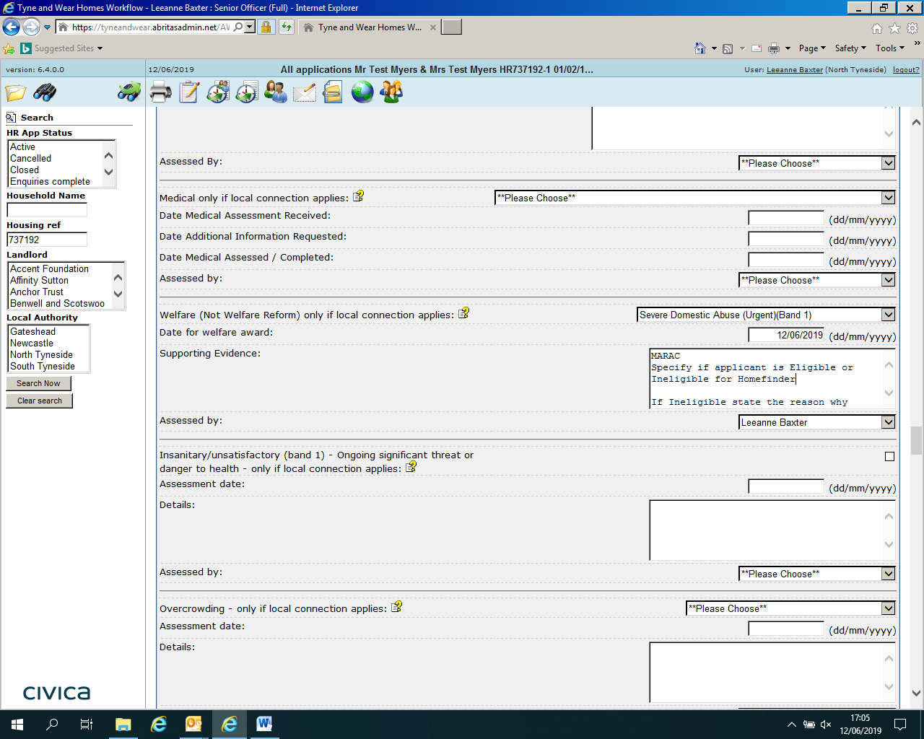

Exceptional circumstances for local connection assessed and awarded

Also ensure that the Direct Match box is ticked and reason for direct match is management discretion:

Applicants need to be disallowed for the entirety of North Tyneside area not just NTC as a housing provider.

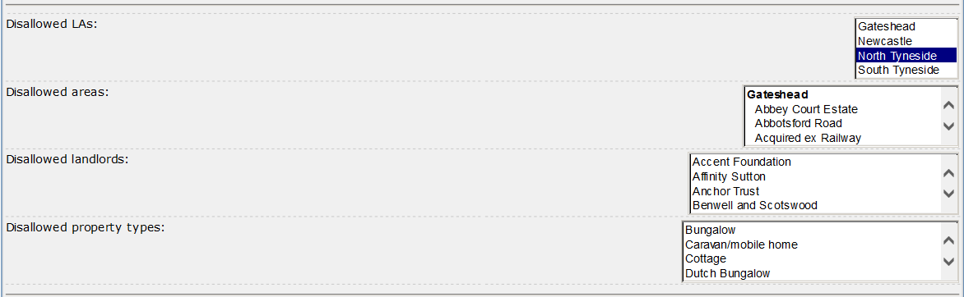

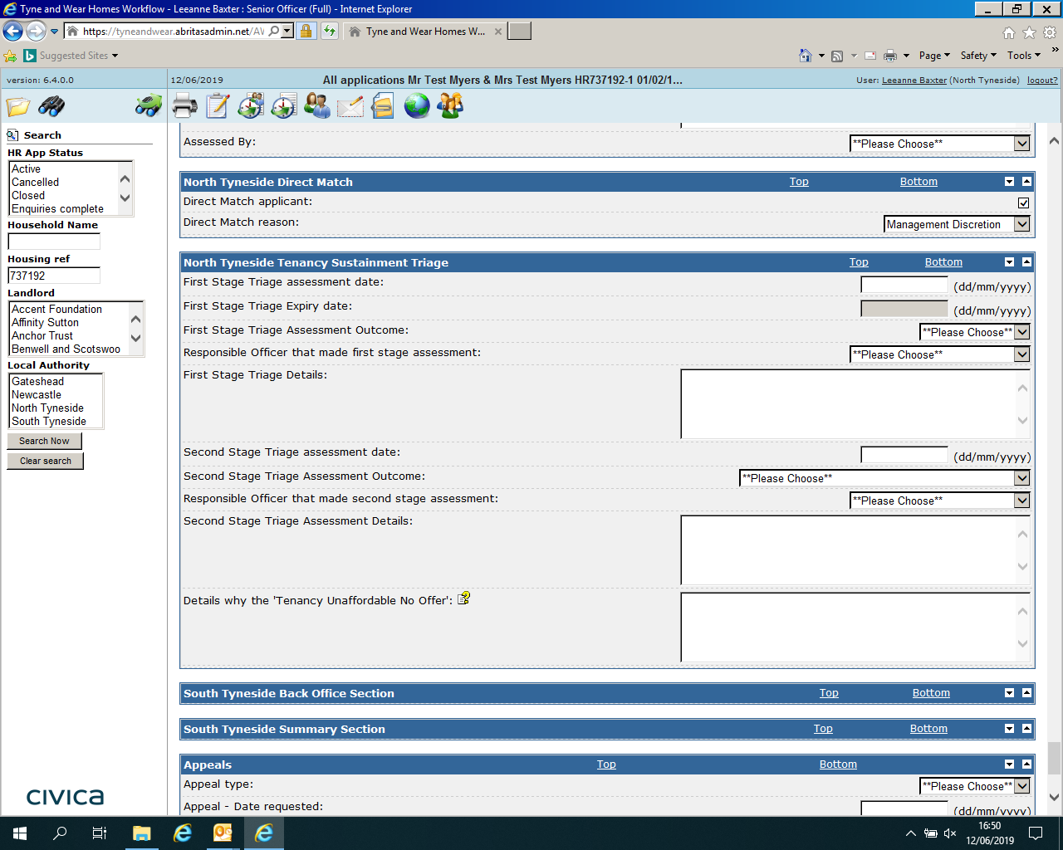

MARAC Single Point of Contact (Georgina) will contact the customers whom have been supported by MARAC and arrange to attend a joint home visit with EHT Officer

MARAC Single Point of Contact sends Direct Let Request to Empty Homes Team by email; Direct Let is given to Katrina or Paul for authorisation

During Home Visit EHT will advise verbally and in writing that the customer has been supported by MARAC and will be given one offer of accommodation

In identifying a property EHT will consider where the applicant has fled from, any property offered will be in a suitable area, i.e. safe for the applicant to reside in long term and sustainable

EHT will contact the customer to make the direct offer of accommodation there will be one offer made

If a customer refuses a suitable offer of accommodation MARAC are advised by EHT, if the refusal is not seen as reasonable by MARAC and the EHT Leader the priority may be removed

EHT will send an email to HF Team Leader to arrange for the application to be reassessed

If a property has not been identified during the first month the case will be reviewed by the EHT in the case of Direct Offers – Reviewed with Team Leader and re-discuss sanctuary with customer

**Customers Fleeing Domestic Abuse (Non-MARAC)**

**Harbour**

A move from Harbour should always be looked at in a planned way and the customer directed through the Homefinder Process.

It has been agreed that the Harbour Support Officer is to assist new residents with completion of an application to Tyne and Wear Homes and provide a 3rd party sharing information document signed by the applicant, confirming information can be shared and discussed with Harbour.

**Local Connection to North Tyneside**

Local Connection to North Tyneside can be any of below:

* They have been resident in the Borough, continuously for at least the last 2years
* They are permanently employed in the Borough or are moving to the Borough for permanent employment
* The applicant has family associations with others living in the Borough. A family member, family association is defined as parents, grandparents, children, brothers or sisters, stepparents, grandchildren, aunts or uncles. Family members whom must have lived in the Borough continuously for the last 2 years
* The applicant was / is a member of the Armed Forces or former Service Personnel and the application is made within five years of discharge or where a bereaved spouse or civil partner of members of the Armed Forces is leaving Service Family Accommodation, following the death of their spouse or partner or where a serving member or former member of the Reserve Forces who needs to move because of a serious injury, medical condition or disability sustained as a result of being in the forces
* They have been accepted as a priority homeless applicant in North Tyneside

and the Authority has a duty to re-house them

* Special Circumstances - Under special circumstances where an applicant has no local connection, a local connection priority may be awarded. Special circumstances may include the need to be near a special medical or support service within the Borough or the applicant or a member of their household is confirmed by the National Witness Mobility Scheme as being on a Witness Protection Scheme

**Is Applicant Eligible?**

**Eligible to Join Tyne and Wear Homes**

All standard checks to be completed

* ID – May not be able to provide due to fleeing home
* Other acceptable documents can be accepted such as letters / reference from Harbour for customers resident 3 months and over
* Has letter of support been included from Harbour?
* 3rd party disclosure form or letter from applicant required before application can be discussed with Harbour
* If arrears priority will be reduced
* If current tenant of North Tyneside Council a home visit is required by the Transfer Assessment Officer

**Applicant is not ready to leave / leaving date not given**

* **Applicants with a Local Connection**

Residents of Harbour with a local connection to North Tyneside will be assessed and placed in Band 3 Harbour

* **No Local Connection**

Residents of Harbour without a local connection to North Tyneside will be assessed and placed in Band 4 reasonable preference.

**Applicant is ready to leave within 3 months**

* **Applicants with a Local Connection**

Customer has local connection to NT, and has been resident in Harbour for minimum 3 months, application will be reassessed

Homefinder Officer prepares Band 2 sign off sheet pass to TL

Band 2 is awarded for a maximum of three months, customer is advised in writing that priority band 2 has been applied, the reason for banding and when the banding will be reviewed.

Band 2 awarded – HF Officer will make a note in their calendar to review application after 3 Months of Band 2 being awarded, if customer has not been successful in gaining permanent accommodation will have their banding re-assessed in accordance to the Allocations policy.

We have agreed with Harbour that there may be some cases under special circumstances which are required to leave refuge before 3 months

**Applicants without a Local Connection in Harbour**

Each case without a local connection to be reviewed by a senior officer (TL or above)

Customers with “No Local Connection” will require “No Local connection Override” applied.

Band 2 awarded - HF Officer will make a note in their calendar to review application after 3 Months of Band 2 being awarded, if customer has not been successful in gaining permanent accommodation will have their banding re-assessed in accordance to the Allocations policy.

**Customers Awarded Band 2 with Former Tenant Arrears**

Must maintain their rent for three months to harbour and have a payment plan in place for any former housing related debt which has been followed - **priority will not be reduced at this stage.**

If customer has not kept to their agreement with Harbour or followed payment plan, they will be given Band 2 leaving supported with reduced priority

Customers resident in Harbour may be heard in MARAC, staff will not request a housing priority as customer is being supported via Homefinder route

**Ineligibility**

An application may be ineligible if the customer:

* Has rent arrears in excess of £500 **unless confirmed financial abuse**
* Is guilty of behaviour which would make them an unsuitable tenant, for example serous anti- social behaviour

If a customer is deemed to be ineligible, they will receive the reasons in writing and will be advised of the conditions that they must meet before they can re-apply for the scheme.

Harbour resident’s ineligible to join the scheme will receive a letter from the Homefinder Team be referred to the Housing Advice Team for triage by sending an email to Housing Advice or telephone 2520.

**Homeless Customers – Applicants Asked to Leave Refuge**

If a customer is at immediate risk of being asked to leave the refuge as there has been a serious incident or the resident poses a risk to others.

**We have agreed:**

Harbour will make contact with the Housing Advice Team by either emailing [housingadvice@northtyneside.gov.uk](mailto:housingadvice@northtyneside.gov.uk) or by telephone 643 2520.

For those cases where this may result in eviction Harbour will contact the Housing Advice Team prior to eviction and the customer will be guided through the homelessness process, Housing Advice Officer will try to prevent the eviction where possible.

The Housing Options Advice Officer (homelessness) will ask the Triage Officer to contact the customer on the same day or possibly the next working day if the referral is received after 4pm to make an appointment for the customer to be seen.

If the customer is to present as roofless the North Tyneside Council Roofless Procedure must be followed.

Before advising the customer to present as roofless, the Harbour Team will have checked vacancies in all other refuges to resolve the situation and advise the Housing Advice Officer which refuges have been contacted in order to stop duplication.

If emergency accommodation is required and there is no temporary accommodation applicants may be placed in B&B which could be outside of North Tyneside, we need to consider where the applicant has fled from.

Customers attending appointments with Housing Advice will be expected to provide confirmation of ID, Landlord references, children’s ID, Child Benefit and a letter from Harbour advising on notice given and how they have conducted tenancy and the reason for leaving.

The customer will be interviewed and may be offered temporary accommodation, all customers placed in Temporary accommodation will be awarded a band 3 and expected to express interest in suitable properties.

**Local Connection (Homelessness)**

Local connection for homeless purposes is 6 months out of the last 12 or 3 years out of 5 years.

If the customer does not have a local connection a referral may be made back to the owning authority if it is deemed safe for them to be referred.

Under the Homelessness Reduction Act the customer will be looked at through the prevention stage, relief stage and final decision stage and appropriate bandings will be awarded as per North Tyneside Allocations Policy.

* Prevention – 56 days, during this time the customer will be placed into Band 5
* Relief – 56 days during this time the customer will be placed in Band 3
* Homelessness investigation decision will be reached within a maximum of 112 days

**Customers stating domestic abuse as their main reason for rehousing (not in refuge) but residents of North Tyneside or have a local connection to North Tyneside**

Homefinder to deal with all applications, however if customer contacts HAT first, they will be given advice to complete an online application form and advice on what information is required / to contact Homefinder for further advice or guidance.

Standard Checks completed including **checking streetwise** for record of any incidents, check with Community Protection Team if involved.

**Has a CAADA been completed?**

CAADA must be completed with all customers stating DA as main reason for rehousing, during this conversation find out if there are any dedicated support workers i.e. Harbour, Family Partner, Police etc…

Discuss Sanctuary with customer – can they remain in their home if additional locks etc… are fitted?

**Sanctuary Referrals to: - Helen White via email using referral form**

**Medium and Low Risk Domestic Abuse Cases**

The Police will provide written confirmation from a sergeant or above stating the risk level of an applicant

If the letter states the applicant is medium or low risk then we will offer sanctuary, regardless of whether the customer presents at HAT or Homefinder.

North Tyneside Council offer the sanctuary scheme to reduce the risk to the applicant and allow them to remain in their home, we have a process in place to reassess the application should there be further incidents

**Sanctuary Referral**

Band 5 (Local Connection)

Band 6 (No Local Connection)

**Monitoring of Case**

If the customer contacts to advise future incidents are reported to support agencies or the police, CAADA is completed and MARAC referral made following new incidents

**Following process below If additional support is provided after initial assessment of application**

Where a customer is being supported by Northumbria Police, we need to ask the officer what has been done to protect the victim i.e. injunctions including non-molestation orders and occupation orders, restraining orders.

If victim is now seen to be at increased risk and this is verified by Police Sergeant MARAC or Community Protection Officer and no additional safety measures can be put in place a letter of support is required to be considered for rehousing.

Letters of support must come from a sergeant prepare Band 1 or 2 paperwork and pass to Team Leader for signature

**Band 1 or 2 – to be determined by TL or above**

**Current NTC Tenants**

Things to be considered

* Is the customer able to stay in their own home?
* Has the victim had to flee their home as the perpetrator is living there? If so, Inform Community Protection of case details as they can investigate the perpetrator – 3333 / Community Protection inbox
* Is there risk of serious harm / risk to life therefore customer cannot remain at home, if so refer to HAT for urgent triage / allocation of refuge accommodation
* If victim is still at home what is the level or risk? Is there additional supporting information or evidence available?
* Has the customer contacted Harbour – Offer to make a referral for them

**Applicants without a Local Connection to North Tyneside**

* Applicants without a local connection are awarded Band 4 reasonable preference
* Applicants without a local connection presenting as high risk we require either
  + MARAC are requesting the victim be rehoused in North Tyneside as it is unsafe for them to remain in their home borough

OR

* + Support from a Police Sergeant, IDVA or DVO
* Each case without a local connection to be reviewed by a senior officer (TL or above)
* Customers with “No Local Connection” will require “No Local connection Override” applied and relevant information recorded in the back office

**Refusals**

Under policy customers refusing three suitable offers of accommodation are disallowed from bidding on NTC for three months

Customers supported by MARAC and recommended for a direct offer are given one offer of accommodation, if the customer refuses this for a “reasonable” reason we endeavour to make an alternative “like for like” offer of accommodation.

Our main priority is the safety of the customer

Reasonable reasons include location of perpetrator, name and details to be given or details of any other person they are at risk from

If NTC feels this offer is suitable and the customer’s reason for refusal is “unreasonable” we will advise the MARAC co-ordinator of the refusal:

* EHT will inform HF of the refusal
* HF will reassess the application
* **HF re-offer sanctuary**
* If the customer is ineligible, then the application is closed, and the customer informed in writing

Unreasonable reasons include, furniture doesn’t fit, property too far to travel, to be discussed with Team Leader

**Customers with Debt Relief or Bankruptcy Orders**

Section 4.2 –Assessment of Ineligibility North Tyneside Council reserves the right, when determining the suitability of an applicant, to assess the suitability of all proposed members of the household, not only the applicant (s). This determination can be re-assessed at any point to ensure the suitability of the application. This will include the way in which any applicant or household member has conducted any current or former tenancies.

Please see section 4.2 (page 11) regarding rent arrears and housing related debt.

Applications received from customers with either Debt Relief or Bankruptcy Orders are assessed in line with North Tyneside Council Lettings Policy, where a customer has declared that they have either order follow process below:

* Application Received
* If not supplied, request a copy of either the DRO or BO from customer, securely attach this to the application
* Where housing related debt exists i.e. rent arrears make application ineligible, for both transfers (existing tenants) and non- transfers
* In the case of existing NTC tenants consider, how the debts occurred, are they under occupying or is there any other vulnerabilities? is their current home a family home which is high demand and could be utilised by NTC
* **Has the applicant kept their current rent account in order for the last 12 months?**
* Speak to Neighbourhood Team Leader to advise them to consider a direct let to more suitable accommodation
* **Transfer Applicants with a bankruptcy order are ineligible for 12 months from the date of issue eg order issued 16.06.20, ineligible until 16.06.21**.
* Transfer cases – await outcome of discussion with TL
* For non-transfers - Update system and send customer ineligible letter stating policy
* If customer appeals this will be reviewed by a Team Leader or above, whereby any exceptional circumstances will be considered
* If an ineligible customer states that they **are or about to** become homeless refer to HAT
* Dependent upon outcome of homelessness investigation customer may be made a direct offer

**Existing Tenants of North Tyneside Council**

Tenants without any housing need are not eligible to apply for rehousing until they have lived in their home for 12 months or more.

Exceptions to this are:

* Customers under occupying and affected by welfare reform
* Fleeing domestic abuse, high risk supported by a Police Sergeant or MARAC
* Fleeing Harassment, supported by a Police Sergeant
* Customers needing to move due to a medical need which has occurred after tenancy commencement
* Any other exceptional circumstance as agreed with Team Leader

**New Transfer and 10 Year Tenancy Applications**

* Homefinder complete usual checks
* Send an email to Transfer Assessment Officer with the application reference number stating home visit required – current tenant – new application / 10 year tenancy
* HF Officer place application in suspended state
* Note in CRM – Referred to Transfer Assessment Officer
* Transfer Assessment Officer visits within 10 working days and reports the outcome to HF Officer
* If the property is satisfactory, any additional checks completed, account activated by Homefinder and welcome letter sent
* If the property is not satisfactory, the Transfer Assessment Officer will give the customer a plan with timescale of 35 days to bring property to the expected standard during which time the application will be suspended.
* If the applicant fails to bring the property up to standard within 35 days, the Empty Homes Team will advise Homefinder that the application is to be closed and the applicant will need to re-apply once their property is of the expected standard

**Under Occupation**

Applicants under occupying a NTC home may qualify for Band 2 priority, this is not awarded for “like for like” properties

Before awarding this priority, a home visit is required from the Transfer Officer

**Customers in Arrears due to Universal Credit or other exceptional circs**

* Was the applicant in arrears prior to Universal Credit or another situation which has prompted them to want to move?
* Does the customer have a repayment plan in place?
* If the applicant is a current tenant discuss this with the Neighbourhood Officer
* If the customer has former tenant arrears, talk to them about this and pass their details to the Former Tenants Arrears Team
* Discuss case with a Team Leader
* Note any arrears on the welcome letter if the arrears increase above £500 close the application and write to the customer to inform them of the decision and the conditions in which they can re-apply

**Current Tenants Applying to Transfer**

**Applicant has not lived in their current NTC home for at least 12 months**

Officer completes assessment checks start date of current tenancy

Applicant has no identified housing need – Letter sent to advise application has been closed (Ineligible to Join) If they only request assessment from North Tyneside the application is closed

If applicant is requesting to be assessed by other areas i.e. South Tyneside, YHN, and Gateshead do not close application - **disallow for North Tyneside, send email to other authorities advising of ineligibility for NTC and request from customer to be assessed letter sent by assessing officer to advise that application is ineligible with North Tyneside.**

OR

Applicant has a housing need as detailed below, change in circumstances since start of tenancy - if so what? Examples as below:

* Unable to afford the rent (welfare reform) – Northgate / Neighbourhood Teams, assess affordability using **NEW financial assessment tool**
* Financial - Signposting to CAB, Support Services, email to Neighbourhood officer regarding the case for further understanding
* Has the household make up changed, overcrowding – how has this happened, more detail required, is there intentionality i.e. have they caused the situation
* Fleeing Domestic Abuse – Suspended until information received from MARAC / Harbour / Police Domestic Violence Officer/IDVA
* Medical – medical form issued and referred to OT (if applicable) / TL, was the medical existing at commencement of tenancy has anything changed?
* Are they registered for mutual exchange? If not, promote applicant to register as an alternative housing option
* Any other exceptional circumstances – to be discussed with a team leader

Officer completes assessment completing standard verification checks:

Liquid Logic

Streetwise

Northgate

Debtors

In both scenarios use letter: **NTC applicant ineligible** amend letter to suit case

**Applicants age 60 and under**

**Current Homeowners are not eligible to join Tyne and Wear Homes unless exceptional circumstances exist**

Other applicants under 60 with savings or assets in excess of £100k or with a household income of £50k are **ineligible**

Non-Homeowner applicants under 60 without a £50k income or under £100k assets or savings are **eligible**

Households with enough resources i.e. household income of £50k &/or £100k in savings / equity are not eligible to join the register this can include spouse / partner income who may not be a joint applicant.

Officer checks the household income section of the back office, if the applicant has enough resources the application is closed, and the applicant informed in writing using “North Tyneside HF Nev2 Ineligible to Join” letter and advised of the reason for ineligibility.

**If customer indicates a vulnerability which** may include but not limited to:

* Financial – Financial Assessment to be issued

Additional guidance around financial assessment – regarding debts, family debts and non-regulated loans not provided by a member of Financial Conduct Authority cannot be considered as priority debts

* Fleeing Domestic Abuse – Suspended until information received from MARAC / Harbour / Police Domestic Violence Officer/IDVA
* Fleeing Harassment – information from Community Protection/ support from a sergeant or above stating the risk to applicant
* Medical – medical form issued and referred to OT (if applicable) / TL, was the medical existing at commencement of tenancy has anything changed? Procedure will reflect only if a band 1 or 2 is likely to be awarded

If there are other exceptional circumstances as per NTC lettings policy discuss with a team leader