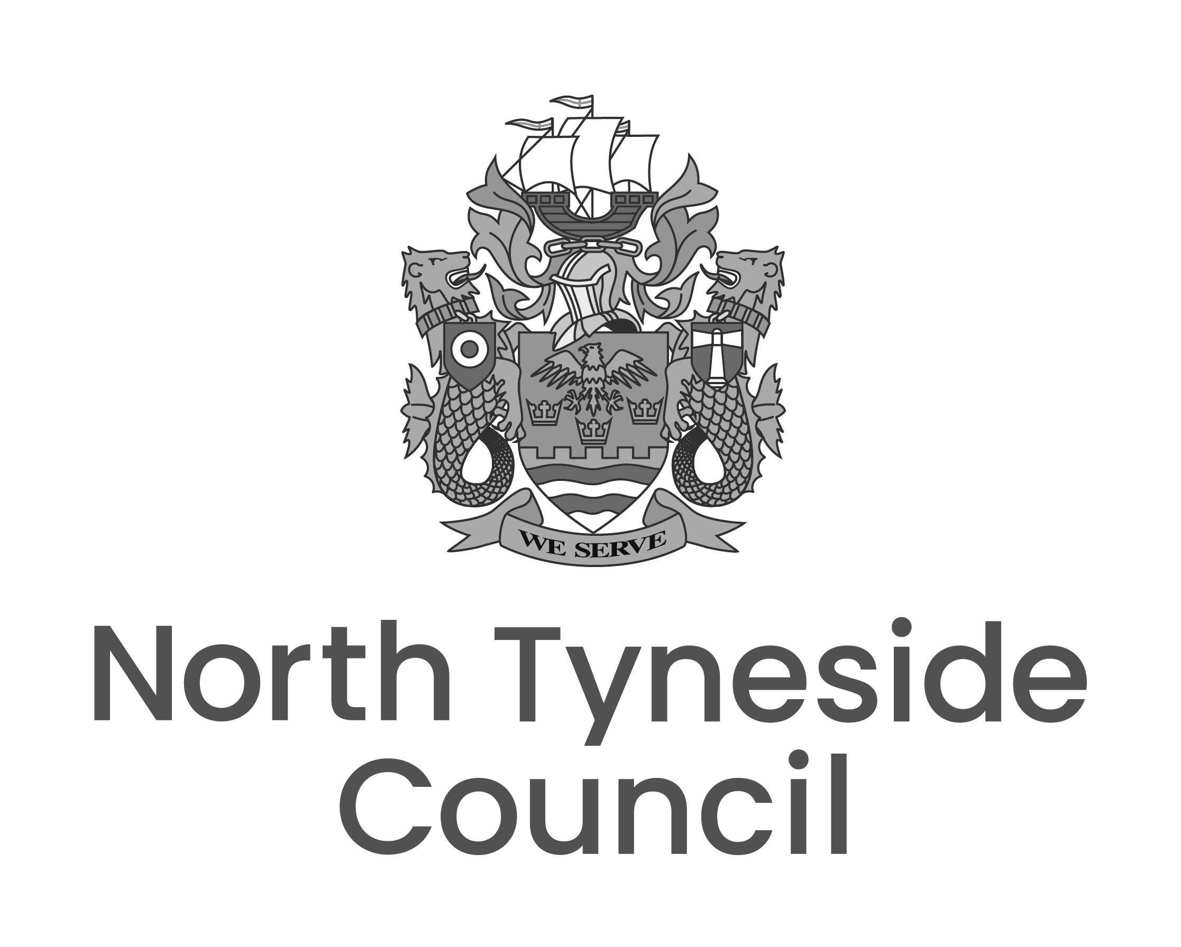

North Tyneside Council

We are seeking applications from suitable organisations that are interested in tendering for the following.

Title
Contract 22 Air Conditioning Maintenance
Use the link above to find the direct link to the opportunity on the portal

Link to all the OPEN tendering opportunities:
Browse Opportunities - Open | Developed by Nepo
Additional info
The following Framework Contract will ensure availability of skilled Contractors to deliver the Programmed Works requiring differing values and complexities as required.

The Authority (North Tyneside Council) will be acting as Principal Contractor and successful Contractors will be in capacity of a Sub-Contractor.
Occasionally the successful Contractor’s may be required to act as Principal Contractor to the Authority.

Contractors are required to hold F-Gas accreditation or equivalent.

The Authority is seeking Tenders to enter into a framework agreement (Framework) to carry out Air Conditioning Maintenance Works across its portfolio of schools, leisure centres and public buildings. Work will include planned preventative maintenance, statutory compliance assessments and inspections and reactive maintenance or repair works as required.

Following this tender exercise, it is envisaged that 5 Contractors will be appointed to the Framework.

Successfully awarded Contractors will be required to work together with North Tyneside Council (the Authority) to drive improvements and support the aims and ambitions of the Contract.

The framework will consist of an initial term of two years, with two further options to extend by up to 12 months each at the sole discretion of the Authority. Works are expected to commence in June 2025.

Interested bidders must access the Tender documents for further information, which are available to download immediately after registering your interest in this opportunity. Please refer to the Authority Requirements for more information.

Further information can be found once you have registered your interest via the OPEN Portal, the link is in the highlighted Contract title above which gives immediate access to the tender documents. Tenderers are reminded to fully read ALL the tender documents. Unregistered suppliers will be re-directed to a registration page, see further below.

Start Date | Contract Duration
1st June 2025 | 24 months with the option to extend for a further 2 x 12 months
Open Portal Reference | Tender submission deadline
OPEN2024226 | Before 12 noon on 17th March 2025.

You can register your interest against this opportunity and gain direct access to the tender documents on the Open electronic tendering portal on the web site using the link in the title above.

Expressions of interest and tender submissions must be received via the Open electronic tendering portal. Email applications or tender submissions will not be accepted. As soon as you register interest in the opportunity you will have immediate access to the tender pack in the portal.

Any clarification questions or requests for further information must be sent via the correspondence section on the Open electronic tendering portal.

Unregistered suppliers will be directed to create an account before they can register interest. Everything you need to help you get the most out of Open is available at the Open Supplier Hub including instructions, videos and how to guides use link below
Open | NEPO

No previous application or expression of interest shall be taken as an application for the purposes of this notice.

