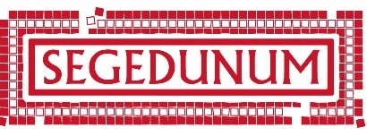**Home Educators’ Sessions at Segedunum Roman Fort**

Mini Life in the Fort

What was it like to be a Roman soldier?

Children pretend to be new recruits in the Roman army and arrive at Segedunum Fort for their training. They will learn how to march and will attend a 'kit training' session in which an adult officer will get dressed in armour and equipped with weapons. They will also make their own Roman helmet before learning how to fight as a Roman soldier.

This session is aimed at KS2 level children. We ask that parents are responsible for children on their visits and accompany the children on the visit. We suggest that younger siblings aren’t in attendance, except for babes in arms. This is due to room capacity and for health and safety due to the objects in use.

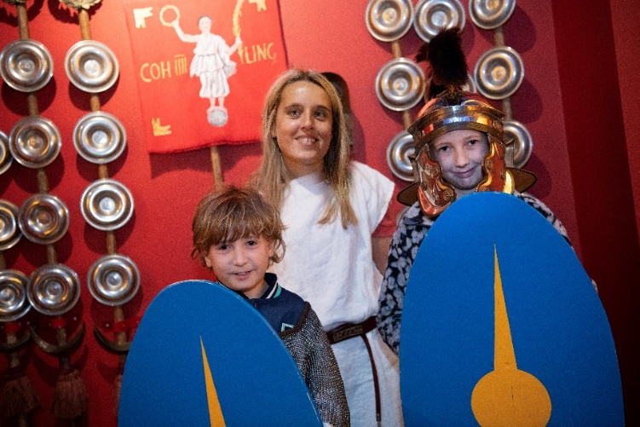**£5 per child.**

[**https://segedunumromanfort.org.uk/whats-on/mini-life-in-the-fort**](https://segedunumromanfort.org.uk/whats-on/mini-life-in-the-fort)

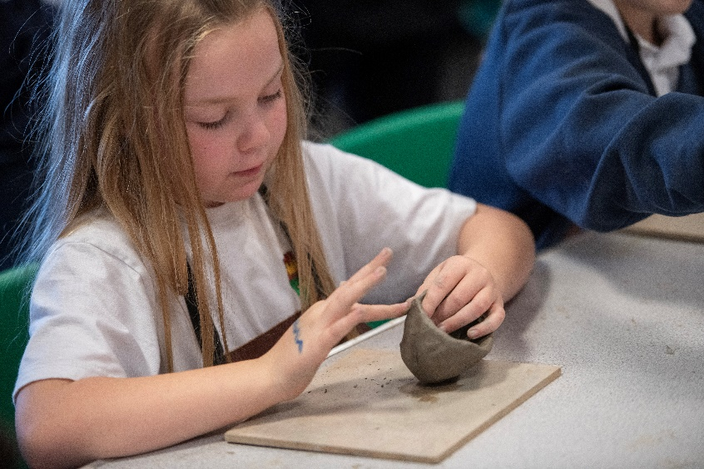Prehistoric Pottery

Take a potter's tour through time and discover the skills of the ancients. Have a go at making a Bronze Age pot based on the characteristic features and designs of that period.

This session is aimed at KS2 level children. We ask that parents are responsible for children on their visits and accompany the children on the visit. We suggest that younger siblings aren’t in attendance, except for babes in arms. This is due to room capacity.

**£5 per child.**

[**https://segedunumromanfort.org.uk/whats-on/prehistoric-pottery-home-educators**](https://segedunumromanfort.org.uk/whats-on/prehistoric-pottery-home-educators)

Roman Craft Session

Children can have a go at taking part in a carousel of Roman craft activities including embossing, making a mosaic tile, making a bath bag and making clay heads/ coins.

This session is aimed at KS1 and KS2 level children. We ask that parents are responsible for children on their visits and accompany the children on the visit. We suggest that younger siblings aren’t in attendance, except for babes in arms. This is due to room capacity.

**£5 per child.**

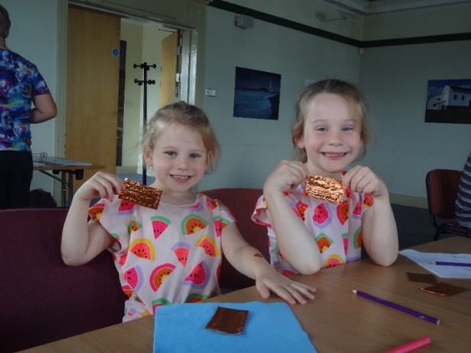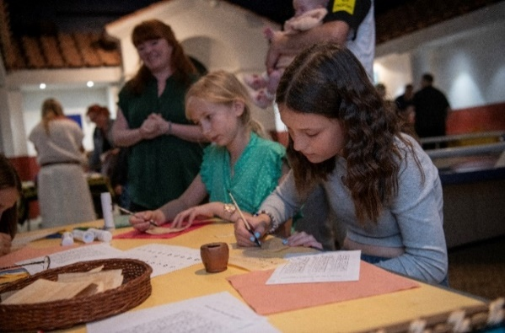[**https://segedunumromanfort.org.uk/whats-on/roman-crafts**](https://segedunumromanfort.org.uk/whats-on/roman-crafts)

Mini Boudica’s Britannia

Step back in time with Gratta from the Brigantes as the gallery is transformed into a Celtic home. Children will explore the art, beliefs and ways of life of tribal Britons. They will learn about the different types of food they ate compared to the Romans, decorate their hands, make a knot bracelet and learn how to build a wattle fence. To finish, the children will settle in around a crackling fire to hear the story of Boudica.

This session is aimed at KS2 level children. We ask that parents are responsible for children on their visits and accompany the children on the visit. We suggest that younger siblings aren’t in attendance, except for babes in arms. This is due to room capacity.

**£5 per child.**

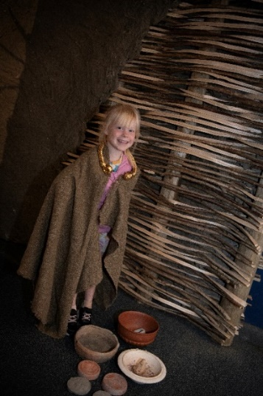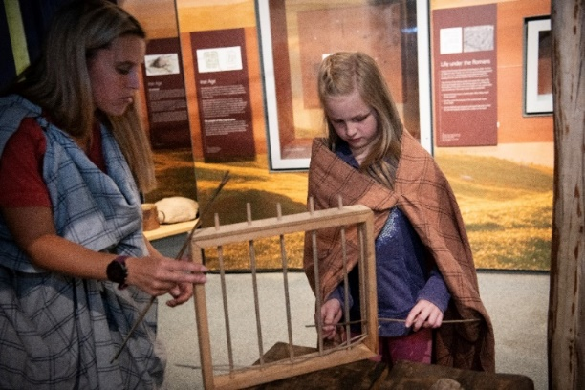<https://segedunumromanfort.org.uk/whats-on/mini-boudicas-britannia>

To book any of these sessions or to be added to our mailing list then please contact- [segedunumlearningbookings@northeastmuseums.org.uk](mailto:segedunumlearningbookings@northeastmuseums.org.uk)