

Local Plan Policy: Hot Food Takeaways Review

August 2025

Contents
1. Introduction 3
2. Background Error! Bookmark not defined.
3. National Guidance Error! Bookmark not defined.
4. Planning Policy Context 4
National Error! Bookmark not defined.
Local Error! Bookmark not defined.
5. Nutrition Data on Hot Food Takeaways 6
6. Diet and Disease Mortality 7
7. CVD and Health Inequalities in North Tyneside Error! Bookmark not defined.
8. Diet and Disease Morbidity Error! Bookmark not defined.
9. Childhood Obesity Data 12
10 Adult Obesity Evidence 17
11. Prevalence and Location of Hot Food Takeaways 18
Proximity of Hot Food Takeaways to Schools 19
Prevalence of Hot Food Takeaways per Ward 18
North Tyneside’s Retail Centres 21
12. Overview 22
Outcomes in Health 22
Childhood Obesity Error! Bookmark not defined.
Hot Food Takeaways Error! Bookmark not defined.
13. Conclusion 24

Introduction
The prevalence of obesity in England continues to grow. In 2022/2023, 64% of adults aged 18 and older were estimated to be overweight or living with obesity. Obesity is recognised as a complex public health concern as people living with obesity are at an increased risk of having Cardiovascular Disease (CVD), type 2 diabetes, cancer, respiratory disease, reduced life expectancy and negative impacts on mental health and wellbeing. The importance of supporting healthy outcomes in planning is highlighted within the National Planning Policy Framework
Within North Tyneside there are notable health disparities between residents in different parts of the Borough residents and across the country. Residents in some parts of the Borough experience significantly reduced life expectancy and lower overall quality of life.
As part of the Local Plan’s response Policy DM3.7: ‘Hot Food Takeaways’, was introduced in 2017 to manage the prevalence of and access to, unhealthy foods. This policy was informed by evidence prepared jointly with the Council’s Public Health Team policy to manage and control the prevalence of hot food takeaways was included within the Local Plan. This Review considers the effectiveness of existing policy in managing hot food takeaways and updates evidence of health outcomes – primarily in relation to key measures of the proportion of overweigh and obese residents in North Tyneside.

Planning Policy Context

National Planning Policy Framework
The National Planning Policy Framework (NPPF) December 2024 sets out the principles and role of the planning system in England. Paragraph 90 of the NPPF highlights the importance of supporting the role that town centres play at the heart of communities and paragraph 96 (c) outlines that planning policies should:
“enable and support healthy lives, through both promoting good health and preventing ill-health, especially where this would address identified local health and well-being needs and reduce health inequalities between the most and least deprived communities”.
Paragraph 97 of the NPPF outlines that Local Planning Authorities should:
“Refuse applications for hot food takeaways and fast food outlets:
a) within walking distance of schools and other places where children and young people congregate, unless the location is within a designated town centre; or
b) in locations where there is evidence that a concentration of such uses is having an adverse impact on local health, pollution or anti-social-behaviour”.

National Planning Practice Guidance
The National Planning Practice Guidance (NPPG) is statutory guidance that underpins the NPPF. In relation to health and wellbeing and creating a healthier food environment, the NPPG states that:
“Local planning authorities can have a role by supporting opportunities for communities to access a wide range of healthier food production and consumption choices”.
Local planning policies can seek to restrict the increasing development of particular use classes where proven appropriate. Policies and proposals may need to have a specific regard to the proximity to locations where children and young people congregate, evidence regarding high levels of obesity and deprivation and concentration of specific uses in an area.

North Tyneside Local Plan, 2017
The North Tyneside Local Plan was adopted in July 2017 and outlines the material planning policy considerations for the Borough. Policy S1.2: ‘Spatial Strategy for Health and Wellbeing’ sets the strategic basis to maintain and enhance the health and wellbeing of residents. Local Plan policy DM3.7: ‘Hot Food Takeaways’ goes further to outline instances where hot food takeaways outlets (previously Use Class A5 units, now Sui Generis) will not be permitted.
This relates to the physical impacts of hot food takeaways on the environment and residential amenity, the proximity of a proposed takeaway to schools, and the level of childhood obesity within the ward where the proposal is located. This in particular restricts hot food takeaways where more than 15% of the Year 6 pupils or 10% of reception pupils are defined as very overweight / obese.

North Tyneside Council Health and Wellbeing Strategy
The Council’s joint health and wellbeing strategy, ‘Equally Well’, aims to support residents to achieve a healthy weight and promote wellbeing throughout the Borough. It sets out the basis for applying a holistic system-led approach to tackling the inequalities in health outcomes driven by the food environment in North Tyneside.
The Healthy Weight Declaration is a key component of this system wide approach. The declaration outlines 16 commitments set by the Council to achieve its aims regarding health and wellbeing. Effective management of hot food takeaways plays an important role in supporting these commitments and improving the health of the Borough.

Nutrition Data on Hot Food Takeaways
(NICE) guidance outlines that the nutritional content of food from hot food takeaways is poor because it contains high levels of trans fat, saturated fat and salt. NICE Guidance (2010) on prevention of CVD outlines that reducing salt and saturated fat intakes for the population will reduce morbidity and mortality rates from CVD. Furthermore, it states that Trans fats (Industrially produced trans fatty acids [IPTFAs]) are a significant health hazard and that sections of the population who regularly eat fried fast-food may be consuming substantially higher amounts of Trans fats.
Meals consumed from hot food takeaways are generally less healthy than those prepared at home as they are often high in fat, salt, sugar and lack in vitamins and minerals. As a result, regular consumption of food from hot food takeaways has been shown to be a significant factor contributing to the increasing prevalence of obesity.
The UK Health and Safety Agency (UKHSA) (previously Public Health England) highlights that the proliferation of hot food takeaways in communities creates an environment that promotes an unhealthy diet and obesity through high concentrations of advertisement of unhealthy foods and ease of access. The UKHSA provides guidance on the use of planning restrictions to address the over concentration of hot food takeaways through designating ‘exclusion zones’ to restrict the development of takeaway outlets in close proximity to schools and locations frequently visited by families and children.
The Government’s Food Strategy (2022) outlines that obesity impacts people across all demographics. but the lowest socio-economic groups are impacted the most. The link between obesity and lower socio-economic groups can be understood by the higher cost of healthier foods, less skills and knowledge on cooking and increased ease of access to unhealthier food options. The strategy also highlights that, as a result of the COVID-19 pandemic, there has been a rapid growth in the takeaway sector, as well as online aggregators and delivery companies allowing for easier access to unhealthier food choices.

Diet and Disease Mortality
A diet which is high in saturated fat and salt and/or includes Trans fats contributes to the risk of developing cardiovascular disease (CVD), cancers and obesity which in turn increases the risk of type 2 diabetes.
CVD mortality in those aged under 75 years is an important health indicator, used in the Public Health Outcomes Framework for England.
For North Tyneside, CVD mortality for people aged under 75 years is higher than the England average (except for three years in the early 2000s) and is similar to the regional average. Please refer to Figure 1.
At ward level, there are highly significant differences in under 75 years CVD mortality in North Tyneside. Rates range from a high 184.5 per 100,000 people in the former pre-2024 wards of Chirton, to 43.3 per 100,000 people in Monkseaton North.
Map 2 shows the levels of deprivation across the wards in North Tyneside, whilst Figure 2 presents the mortality rate of CVD of persons aged under 75 years per ward in North Tyneside. When comparing the map with Figure 2, there is an emerging correlation between areas with higher levels of deprivation and those with a higher CVD mortality rate.
Diet is an important lifestyle factor which contributes to CVD mortality, but other factors are also important including levels of physical activity and smoking.

Diet, disease and health inequalities
Nationally, The Office for Health Improvement and Disparities assesses the likely factors that contribute to health inequalities (avoidable differences in health) between Local Authority areas across England and within Local Authority areas. This data for North Tyneside is provided on Figures 1 and 2.
The gap in life expectancy between North Tyneside and England for 2021/22 – 2022/23 is 1.3 year for males (England at 79.5 years and North Tyneside at 78.2 years) and is 1 years for females (England at 83.2 years and North Tyneside at 82.2 years). However, the gap in life expectancy within North Tyneside is much greater. For males, it is 11.3 years between the most deprived area and the least deprived area and 11.2 for females. For males, 20.4% of this gap is explained by CVD and for females, 23.6% of the gap is explained by CVD. CVD is the single biggest contributor to inequalities in life expectancy within the Borough.
Figure 1: CVD trend for North Tyneside from 2001 – 2022:
Source: Department of Health and Social Care.

Map 1: Indices of Deprivation 2019, ,Ward and Lower Super Outpur Area
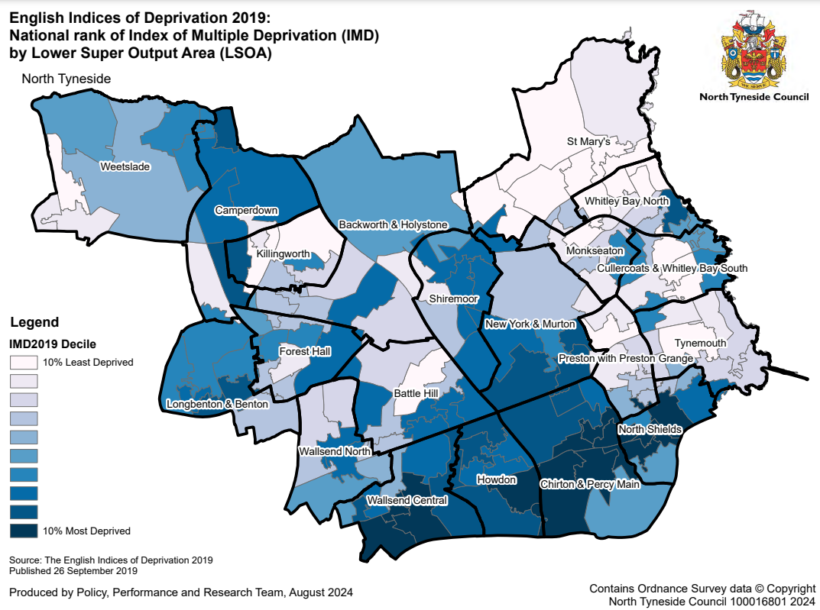

Figure 2: Mortality from CVD per Ward

Source: Department of Health and Social Care.

Figure 3 illustrates the prevalence of Coronary Heart Disease (CHD) in North Tyneside. CHD prevalence (those people living with CHD) in North Tyneside is 3.9%, which is the same as the North East average. However, this is higher than the England average of 3%.
Emergency hospital admissions for CHD by ward vary from 178.9 per 100,000 persons in Chirton, to 81 per 100,000 persons in Weetslade. The North Tyneside average is 126.5 per 100,000 persons.
Diabetes prevalence (those people recorded as living with diabetes) in North Tyneside is 8.7%, which is slightly lower than the England average of 8.9% and the same to the North East average.
Figure 3: Prevalence of CHD in North Tyneside per Ward:
Source: Department of Health and Social Care.

Childhood Obesity Data

National
The National Child Monitoring Programme (NCMP) collects robust evidence on the trends regarding the prevalence of obesity for children in Reception (4-5 years) and Year 6 (10-11 years) in England. Over the 2022/23 and 2023/24 period covered by the NCMP, the prevalence of obesity in Reception children increased from 9.2% in 2021/22 to 9.6% in 2022/23. For Year 6 children, the prevalence of obesity decreased from 22.7% in 2022/23 to 22.1% in 2023/24, however this remains higher than levels recorded in 2018/19 and 2019/20. Obesity prevalence in boys is higher than girls in both Reception and Year 6. For boys in Reception, obesity prevalence was 9.3%, in comparison to 9% of girls. In Year 6, obesity prevalence in boys was 25.1%, whilst obesity prevalence in girls was 20.1%.
National evidence demonstrates a close relationship between levels of deprivation and childhood obesity. For children living in the most deprived areas of the country, obesity prevalence was over twice as high in comparison to children living in the least deprived areas. For Reception children living in the most deprived areas, prevalence of obesity was 12.4%, compared with 5.8% of children living in the least deprived areas. For Year 6 children, the prevalence of obesity was 30.2% in the most deprived areas, whilst the prevalence of obesity was 13.1% in the least deprived areas.

North Tyneside
A report on the most recent NCMP data (2023/2024) identifies that an average of 8.7% of Reception children in North Tyneside are obese, which is lower than the England average of 9.6%. For Year 6 children, an average of 22.3% are obese, which is marginally higher than the England average of 22.1%. The most recent data indicates that the levels of obesity in Year 6 children is recovering back to lower levels recorded in previous years following a spike over the 2020/21 period.
Figure 4: Trend of Childhood Obesity in England and North Tyneside:
Source: National Child Measurement Programme. (Note: Data was not recorded during the 2020/2021 period.)
The data set out in Figures 5 and 6 below, identifies a significant increase in the levels of obesity from children in Reception to children in Year 6. In Reception, the ward with the highest level of obesity was Chirton and Percy Main with 16%, whilst St Mary’s had the lowest level of 4.%. Whereas for levels of obesity in Year 6 children, the ward with the highest level of obesity was Howdon with 34.2%, whereas Whitley Bay North had the lowest level of 11.3%.
In North Tyneside, there is a relationship between levels of deprivation and excess weight in children as 47.2% of Year 6 children in the 10% most deprived areas had excess weight in 2023/2024. This is compared with 23.2% of Year 6 children in the 10% least deprived areas that had excess weight in 2023/2024. As for levels of childhood obesity in relation to deprivation, 33.18% of Year 6 children in the 10% most deprived areas were obese, in comparison to 10.94% of Year 6 children in the least deprived areas.
Figure 5: Prevalence in Reception Children per Ward:

Figure 6: Prevalence in Year 6 children per Ward:
Source: National Child Measurement Programme.

Figure 7: Prevalence of Obesity in Reception and Year 6 Children per Ward (2021/22 to 2023/24):
Ward | Reception (ages 4-5 years) (%) | Year 6 (ages 10-11 years) (%)
Backworth and Holystone | 7.5 | 20.7
Battle Hill | 10.1 | 28.9
Camperdown | 6.5 | 20.4
Chirton & Percy Main | 16.0 | 33.5
Cullercoats & Whitley Bay South | 8.4 | 14.3
Forest Hall | 8.5 | 21.8
Howdon | 10.5 | 34.2
Killingworth | 7.9 | 24.7
Longbenton & Benton | 11.8 | 24.3
Monkseaton | 6.3 | 15.8
New York and Murton | 11.2 | 30.2
North Shields | 7.4 | 26.6
Preston with Preston Grange | 5.8 | 22.6
Shiremoor | 10.4 | 21.8
St Mary’s | 4.3 | 12.9
Tynemouth | 6.6 | 14.5
Wallsend Central | 10.1 | 29.9
Wallsend North | 11.3 | 26.2
Weetslade | 10.0 | 29.5
Whitley Bay North | 6.9 | 11.3
Source: National Child Measurement Programme.
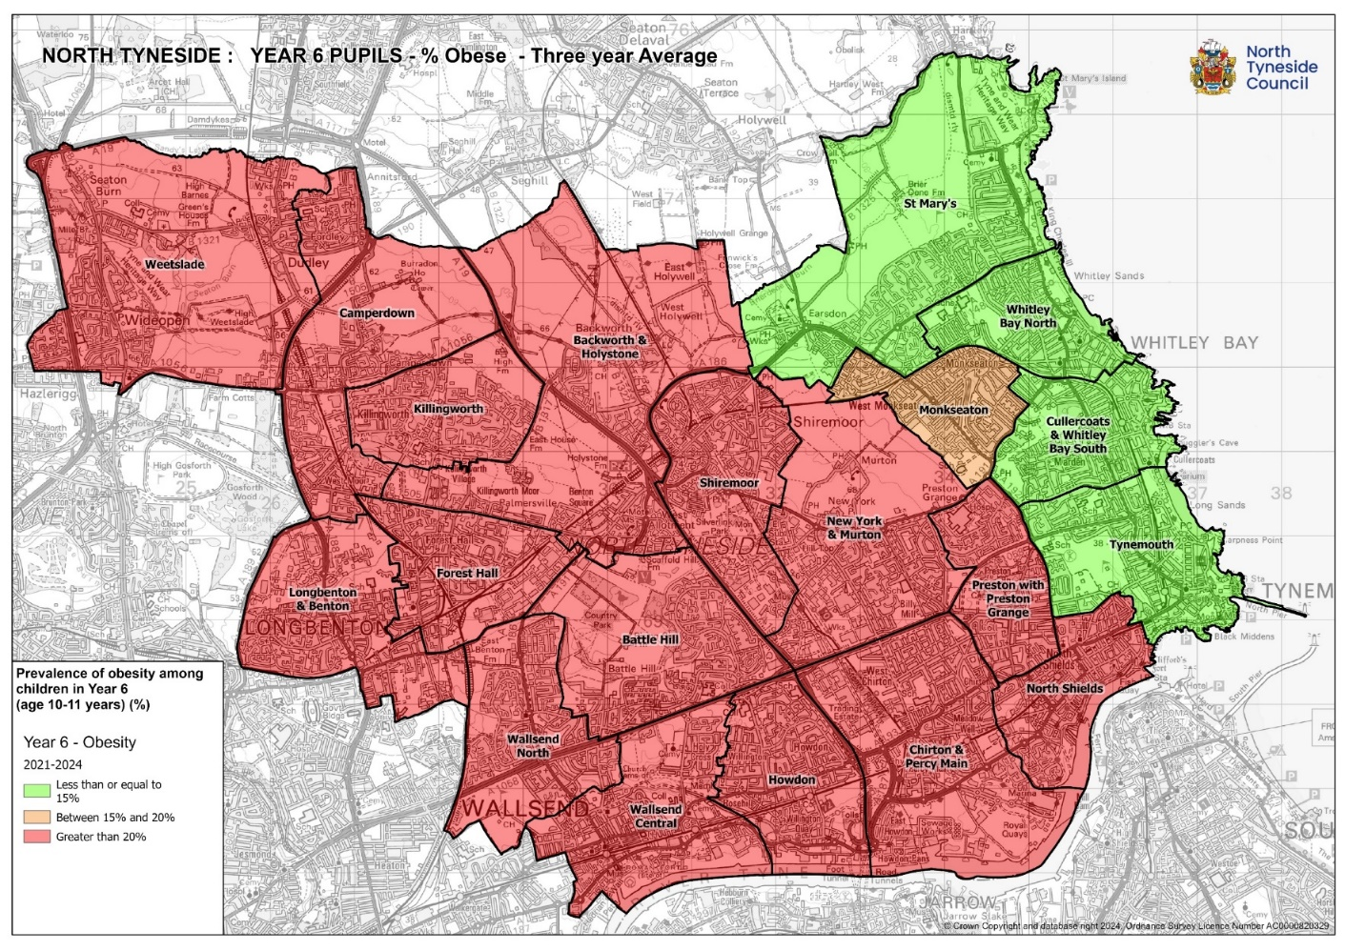
Map 2: Prevalence of obesity among children in Year 6 by Ward

Adult Obesity Evidence
The level of adult obesity and excess weight in North Tyneside is slightly lower than the North East average but is higher than the England average. Please refer to Figure 8 below:
Figure 8: Prevalence excess weight and obesity in Adults (2022/23):
Indicator | North Tyneside | North East Region | England
Adult obesity | 29.8% | 32.2% | 26.2%
Adult excess weight | 63.2% | 70.2% | 64%
Source: Department of Health and Social Care.

Prevalence and Location of Hot Food Takeaways
The National Obesity Observatory has calculated the prevalence of hot food takeaways nationally. The mean number of hot food takeaways in England in 2014 was 86 per 100,000 population. This increased to a mean number of 96.1 hot food takeaways per 100,000 population in 2017 - equivalent to 9.6 takeaways for every 10,000 people.
An analysis of the concentration of hot food takeaways in North Tyneside by ward, including the rate per 10,000 population, has been calculated and is set out in Figure 9 below. These figures illustrate that across the Borough the number of takeaways are equivalent to the national average. However, locally there are significant concentrations in Chiron and Percy Main, Forest Hall, North Shields, Shiremoor, Wallsend Central and Whitley Bay North.

Figure 9: Prevalence of Hot Food Takeaways per Ward
Ward | Hot food takeaway’s per Ward | Population  (2022 mid-year estimate) | Rate per 100,000 people
Backworth and Holystone | 1 | 11,563 | 0.9
Battle Hill | 6 | 10,966 | 5.5
Camperdown | 10 | 8,641 | 11.6
Chirton & Percy Main | 18 | 12,364 | 14.6
Cullercoats & Whitley Bay South | 7 | 10,729 | 6.5
Forest Hall | 19 | 9,281 | 20.5
Howdon | 13 | 12,285 | 10.6
Killingworth | 0 | 8,066 | 0.0
Longbenton & Benton | 4 | 11,232 | 3.6
Monkseaton | 5 | 9,670 | 5.2
New York and Murton | 7 | 9,576 | 7.3
North Shields | 24 | 12,383 | 19.4
Preston with Preston Grange | 4 | 9,504 | 4.2
Shiremoor | 13 | 9,131 | 14.2
St Mary’s | 4 | 10,377 | 3.9
Tynemouth | 4 | 10,521 | 3.8
Wallsend Central | 36 | 10,923 | 33.0
Wallsend North | 5 | 11,970 | 4.2
Weetslade | 7 | 10,691 | 6.5
Whitley Bay North | 24 | 10,614 | 22.60
North Tyneside | 211 | 210,487 | 10.0

Proximity of Hot Food Takeaways to Schools
In North Tyneside, 9 out of the 17 Middle and Secondary Schools have hot food takeaways located within a 400m radius of the schools. Restricting the development of hot food takeaways within a reasonable walking distance of the school (i.e. a 400m radius) will limit exposure to children and access to poor food choices.
Map 3 overleaf, indicates the location of hot food takeaways in relation to schools and parks, including a buffer zone of 400m which relates to the Local Plan policy DM3.7.

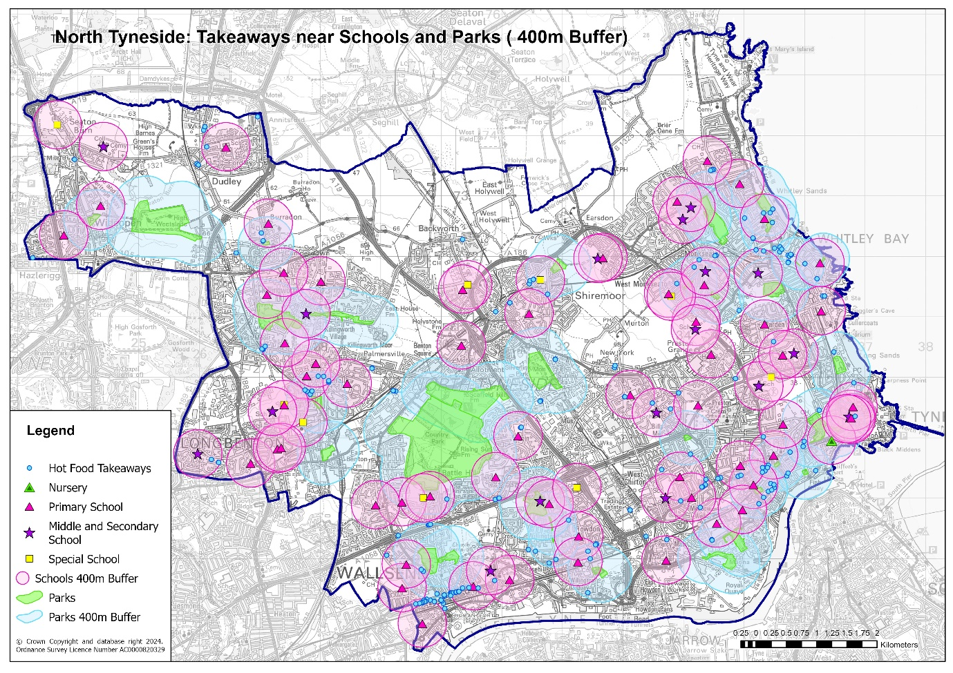
Map 3 : Proximity of takeaways near schools and parks

North Tyneside’s Retail Centres
An important contributing factor to poor diet and health in certain parts of North Tyneside is the distribution and access to unhealthy eating outlets. In certain locations there is an issue where such uses cluster together, reinforcing the ease of access to unhealthy foods. The hot food takeaway policy has been implemented in order to help control the proliferation of and therefore the access to, such uses. There are 211 hot food takeaway outlets in total within North Tyneside, 90 of which are located within designated retail centres.
Figure 9: Total Number of Hot Food Takeaways in Designated Retail Centres
Location | Number | Percent all Takeaways
Town Centres | 66 | 31.2%
North Shields | 15 | 7.1%
Wallsend | 29 | 13.7%
Whitley Bay | 22 | 10.4%
Killingworth | 0 | 0%
District Centres | 11 | 5.3%
Forest Hall | 5 | 2.4%
Monkseaton | 4 | 1.9%
Tynemouth | 1 | 0.5%
Northumberland Park | 1 | 0.5%
Local Centres | 13 | 6.1%
Battle Hill | 3 | 1.4%
Howdon | 2 | 0.9%
Longbenton | 3 | 1.4%
Preston Grange | 1 | 0.5%
Whitley Lodge | 4 | 1.9%
Total within North Tyneside’s designated retail centres | 90 | 42%

The clustering of hot food takeaways, particularly those that are open during the evening and night, can lead to ‘dead’ frontages during the day. This can undermine the retail function of any neighbouring retail premises and impact on the vitality and viability of the area.
The council is committed to developing vibrant retail centres. A key aim is to attract new visitors. When one use dominates an area, it may have a detrimental effect on the image and amenity of that area and the way it is perceived by potential visitors.

Overview of Local Plan policy effectiveness

Outcomes in Health
Since the original health evidence was produced in 2015, health issues related to obesity within North Tyneside continue to exist. This includes a lower than the England average in life expectancy and high levels of CVD and CHD.
With regards to levels of obesity, the data shows that obesity in adults has increased since the original health evidence was produced.
The levels of childhood obesity in Reception and Year 6 children in North Tyneside has fluctuated. The data identifies that the levels of obesity had sharply increased in 2020/21, however this is now recovering back to lower levels recorded in 2018/19. The levels of obesity in Year 6 children continue to present a disparity between coastal wards and the rest of the Borough.
As a result of persisting health issues and increasing levels of obesity, this evidence supports the need for continued intervention through planning policy for hot food takeaway outlets in North Tyneside.

Planning control of hot food takeaways

Since adoption of the current Local Plan policy to manage hot food takeaways, the number of operational outlets in North Tyneside has decreased from 197 to 190 units. Currently a further 21 units are recorded as last used as a hot food takeaway but are presently vacant or otherwise unoccupied. Therefore, it is possible that some new locations could open in locations where the principle use for hot food takeaway is already established.
The Local Plan policy has been successfully applied in defending all appeals against refusals of planning permission for new hot food takeaways. The most recent appeal was dismissed for the proposed change of use of an unoccupied unit into a hot food takeaway outlet in Forest Hall district centre (application reference: 22/00884/FUL).
The Planning Inspector dismissed the appeal due to the requirements outlined in the Local Plan policy and the socio-environmental impacts as a consequence of an additional hot food takeaway in the retail centre. The Inspector stated:
“In this instance, the key harm arising through the development would be the introduction of an additional use that is identified through development plan policy as intrinsically linked to adverse effects on the health of residents”.
With regards to impacts on local levels of childhood obesity and location of hot food takeaways, the Inspector stated:
“Just because the development is located more than 400 metres from a middle or secondary school does not mean that children will not be exposed to its products, and it seems to me that the location within a ward with such high rates of childhood obesity means particular care should be taken in this regard, even if other services and available products, including snacks, may also be a driver of childhood obesity”.

Conclusion
Local Plan policy DM3.7: ‘Hot Food Takeaways’, was adopted in 2017 to address the increasing levels of obesity and related health issues in North Tyneside. The adoption of the policy has been successful in local planning practice and has ensured that new hot food takeaways are only permitted in appropriate locations as set out in the policy requirements.
This review concludes that the Local Plan policy DM3.7 remains a suitable and robust policy for managing proliferation of hot food takeaways.
Latest NPPF and planning guidance, closely reflect current Local Plan policy but make specific exceptions to allow new hot food takeaways within town centre locations. However, a further provision allows for restrictions where there are harmful impacts on health and amenity as a result of concentrations of hot food takeaways.
The evidence presented here demonstrates that there continues to be harmful impacts arising as a result of the concentrations of hot food takeaways that are demonstrated as existing within each of the Borough’s town centres – with the exception of Killingworth town centre.
Looking ahead to the effectiveness of planning controls on hot food takeaways the increasing popularity and ease of access of unhealthy foods via online and use of delivery services is a growing issue for further consideration.

Ministry of Housing, Communities and Local Government, ‘The National Planning Policy Framework’, 2024.
Ministry of Housing, Communities and Local Government ‘National Planning Practice Guidance’, 2022.
North Tyneside Council, ‘The North Tyneside Local Plan 2017 – 2032’, 2017.
North Tyneside Council, ‘Equally Well: A healthier, fairer future for North Tyneside 2021-2025’, 2021.
North Tyneside Council, Healthy Weight Declaration, 2022.
NICE, ‘Public Health Guidance 25: Cardiovascular disease prevention’, 2010.
Albalawi, A., et al., ‘Consumption of takeaway and delivery meals is associated with increased BMI and percent fat among UK biobank participants’, 2022.
Public Health England, ‘Using the planning system to promote healthy weight environments’, 2020.
Ibid., 2020.
Department for Environment, Food and Rural Affairs, ‘Government Food Strategy’, 2022.
Ward data throughout this review may vary due to the adoption of the new ward boundaries in 2024 and availability of data.
Department of Health and Social Care, Fingertips, 2024.
NHS England, ‘The National Child Monitoring Programme’, 2024.
Ibid.
The National Obesity Observatory.
Obesity and the environment, Public Health England, 2018.

