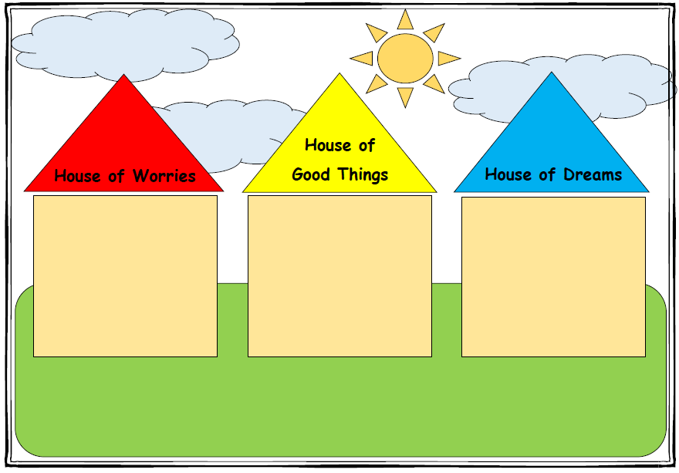

* If you lived in your dream house and your dream house had no worries what would be happening in that house?
* If life were just how you wanted it to be, what would you like to happen?
* Tell me about all the things that are going well in your life
* Lets draw all the things you feel good about
* What do you like most about your family?
* What are your favourite things to do with your mum?
* What are some things that you are worried about in your life?
* Are there things about your family that worry you?
* Let’s draw some of the things about your family that worry you?